**Alexa C# coding using Visual Studio**

1. **Install VS2019**
2. **Install AWS Toolokit for Visual Studio**:

<https://docs.aws.amazon.com/lambda/latest/dg/csharp-package-toolkit.html>

“You can build .NET-based Lambda applications using the Lambda plugin to the [AWS Toolkit for Visual Studio](http://aws.amazon.com/visualstudio/). The toolkit is available as a [Visual Studio extension](https://marketplace.visualstudio.com/items?itemName=AmazonWebServices.AWSToolkitforVisualStudio2017)”

Go to <https://marketplace.visualstudio.com/items?itemName=AmazonWebServices.AWSToolkitforVisualStudio2017>

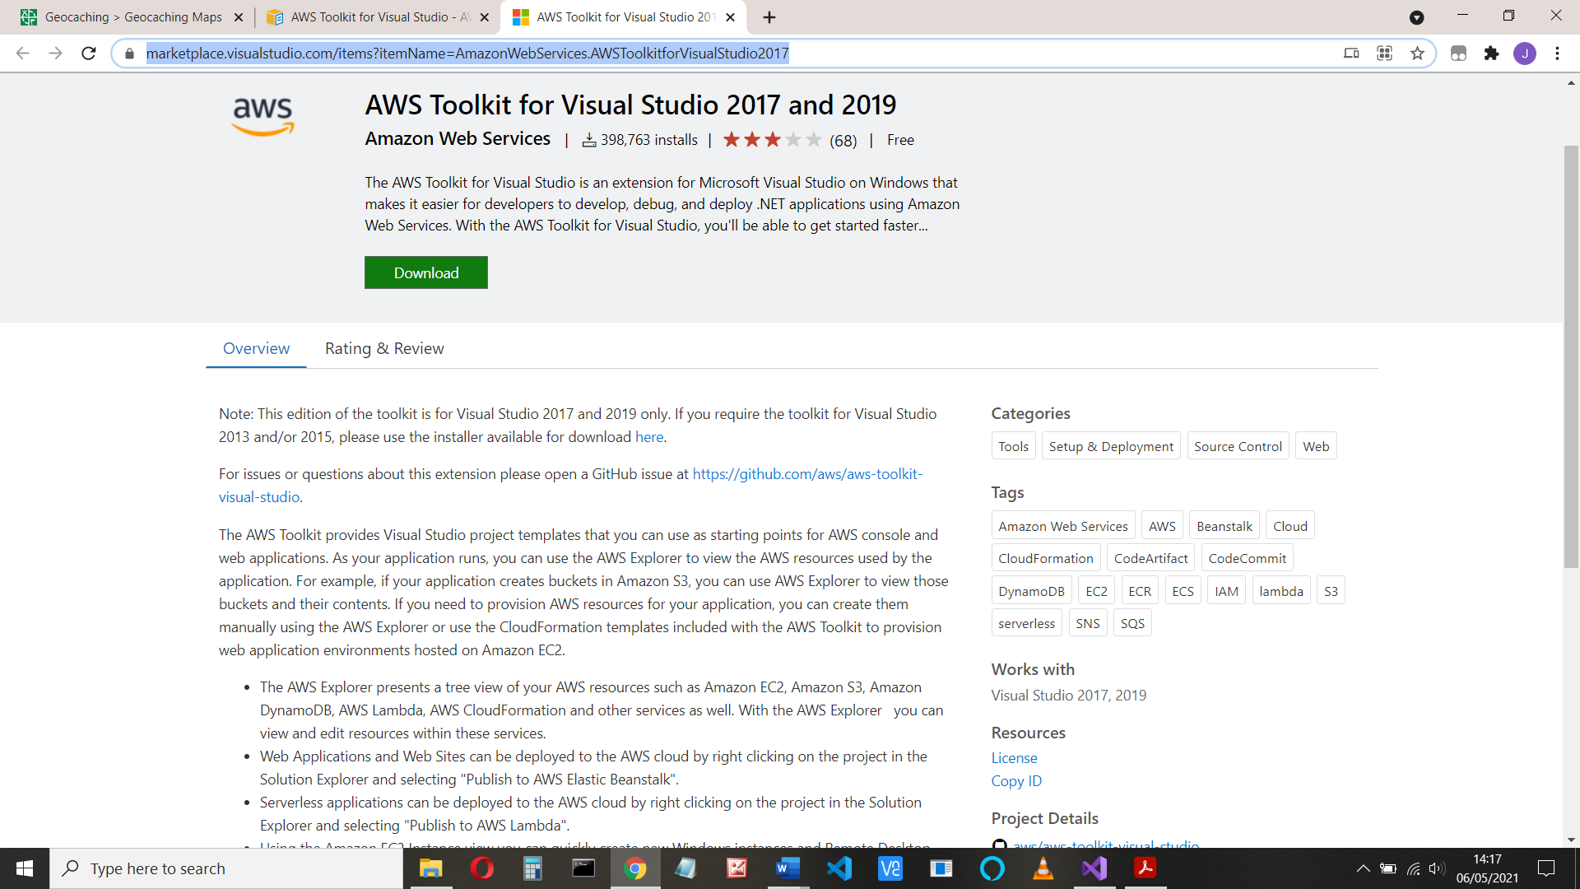

And download the installer. Click on the link to install and Ok when asked.

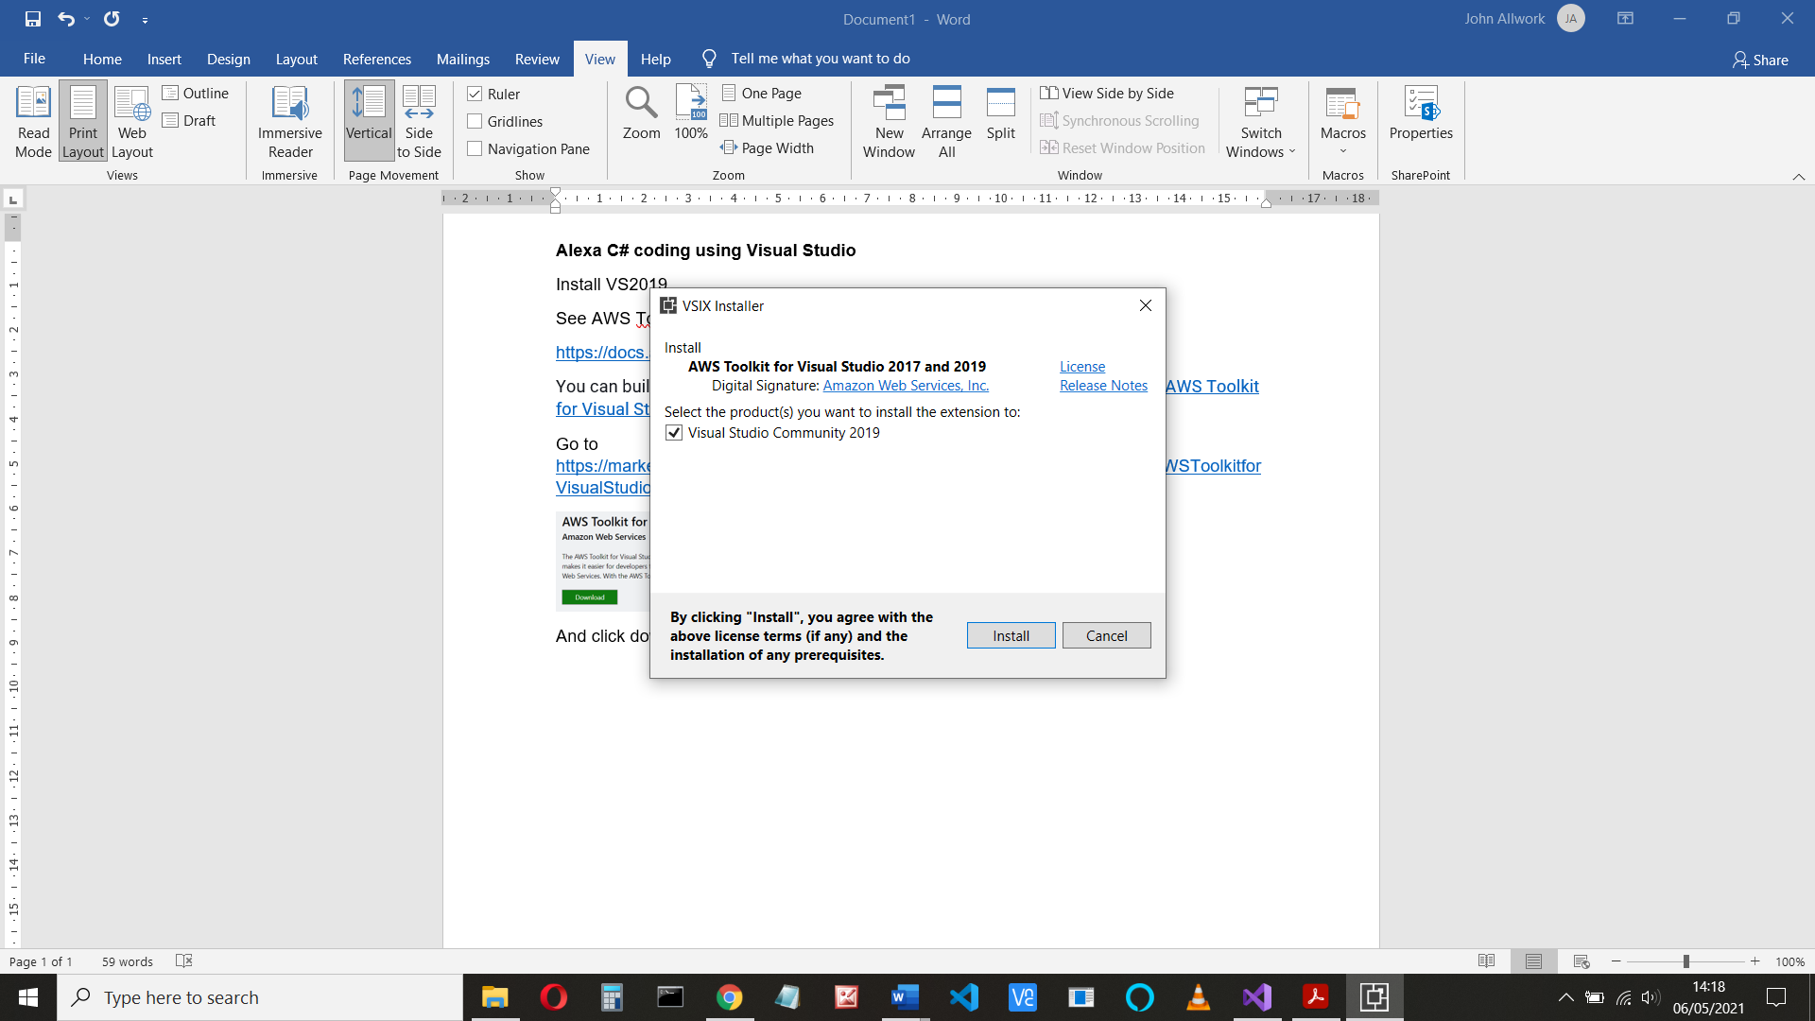

Then click install

1. When that’s done, **start VS2019**

Ref: <https://docs.aws.amazon.com/toolkit-for-visual-studio/latest/user-guide/lambda-build-test-severless-app.html>

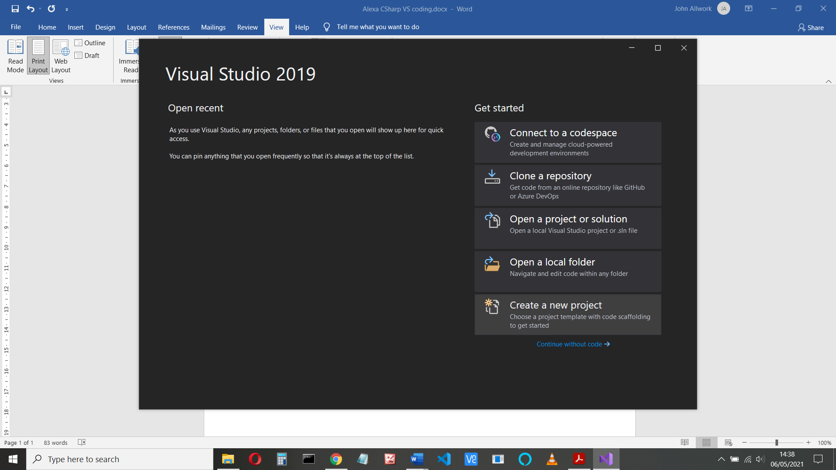

Choose ‘Create a new project’, then choose (or search for) **AWS Lambda Project (.NET Core – C#)** in the installed templates

Note there’s also a version ‘AWS Lambda Project with Tests’ – I don’t know what that is

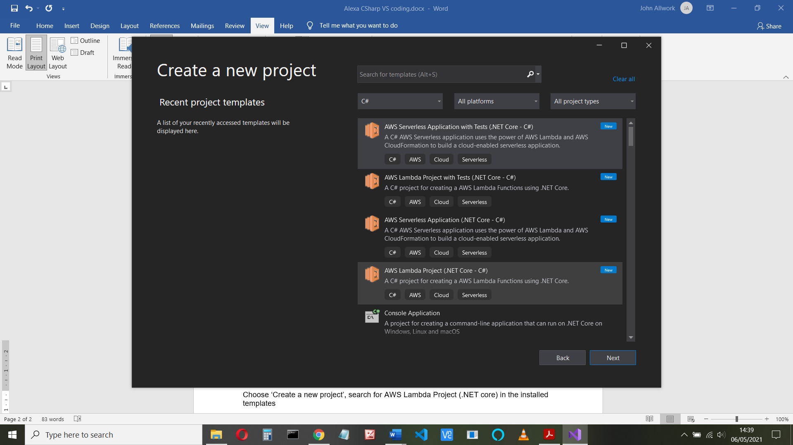

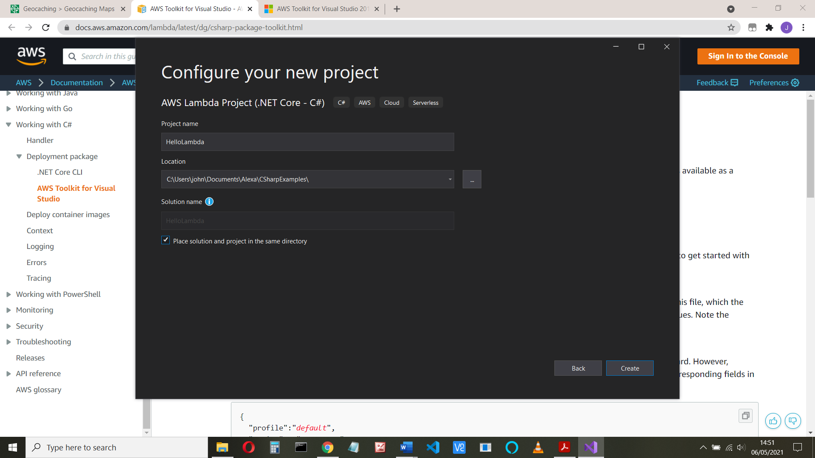

Configure your project – give it a name and location, click ‘Create’ and in the next screen, choose ‘Empty function’ then Finish

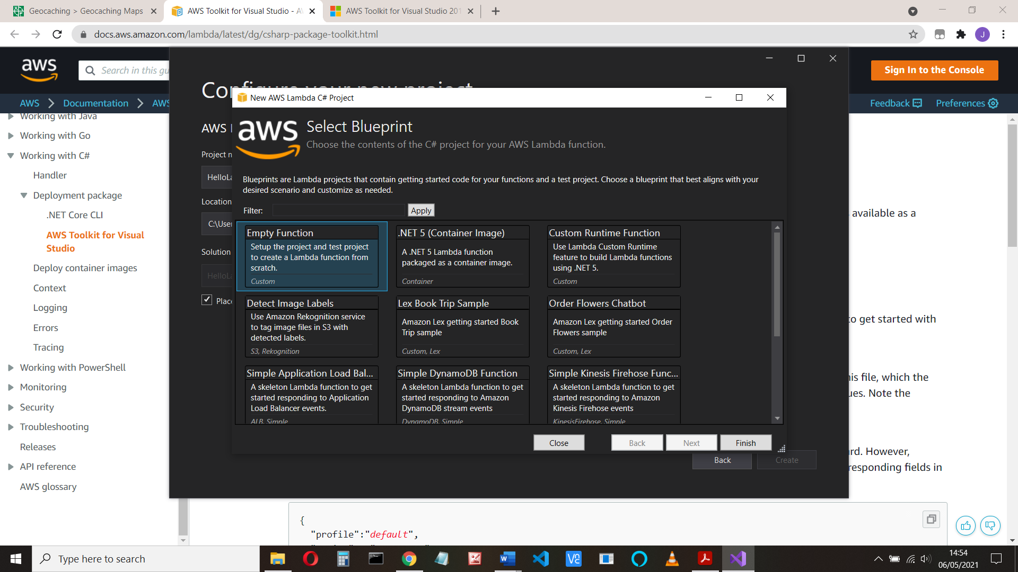

1. **Set up your AWS credentials**.

The first time, you will have to set up your AWS credentials

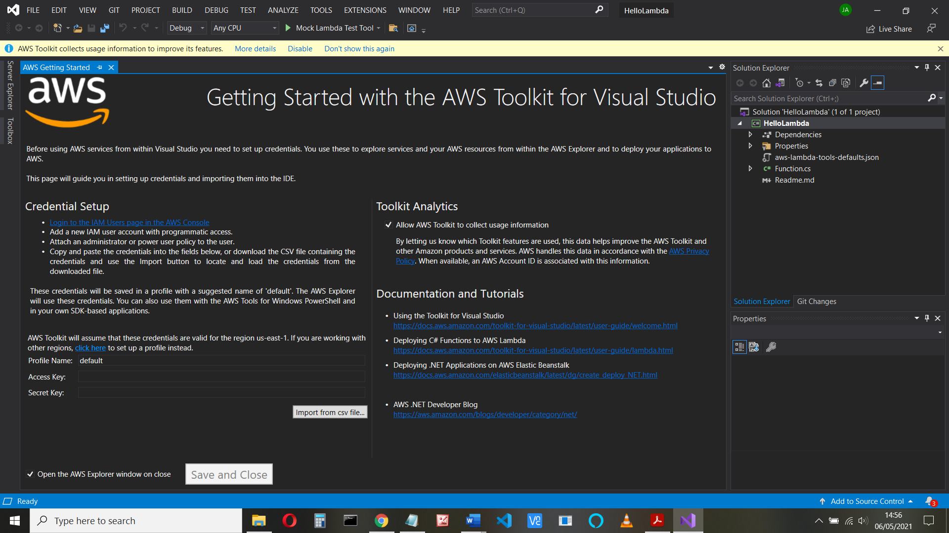

Configuring AWS Credentials

(You do have an AWS account, don’t you?)

Note the section that says this is for us-east-1. If you want elsewhere, click where it says.

**Credential Setup**

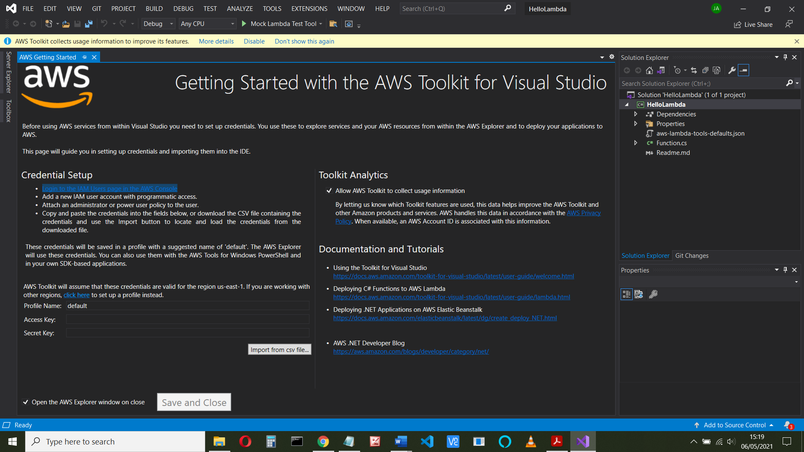

• Login to the IAM Users page in the AWS Console

Login at console.aws.amazon.com, select IAM console and click users

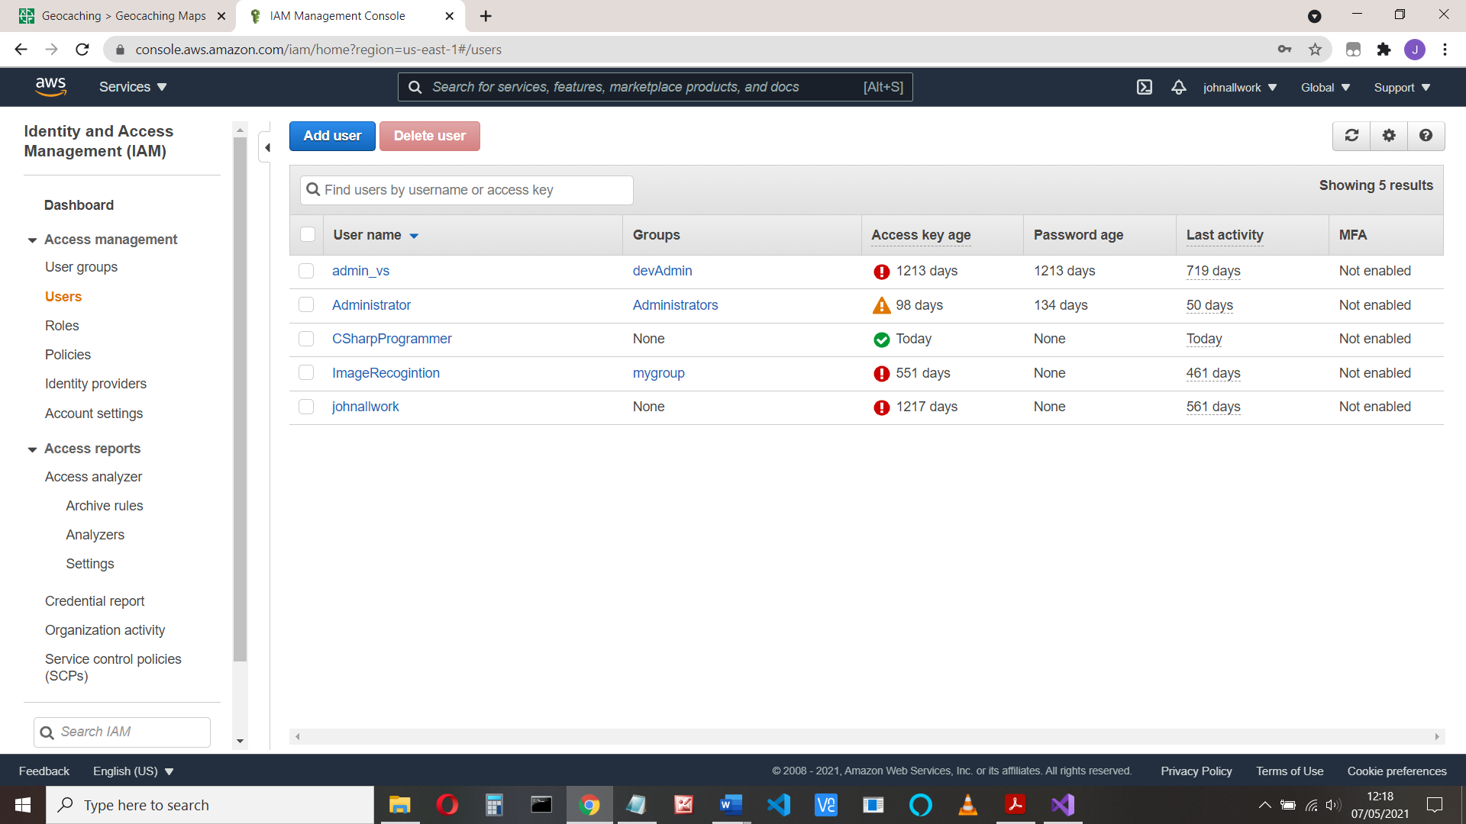

• Click Add use and a new IAM user account with programmatic access.

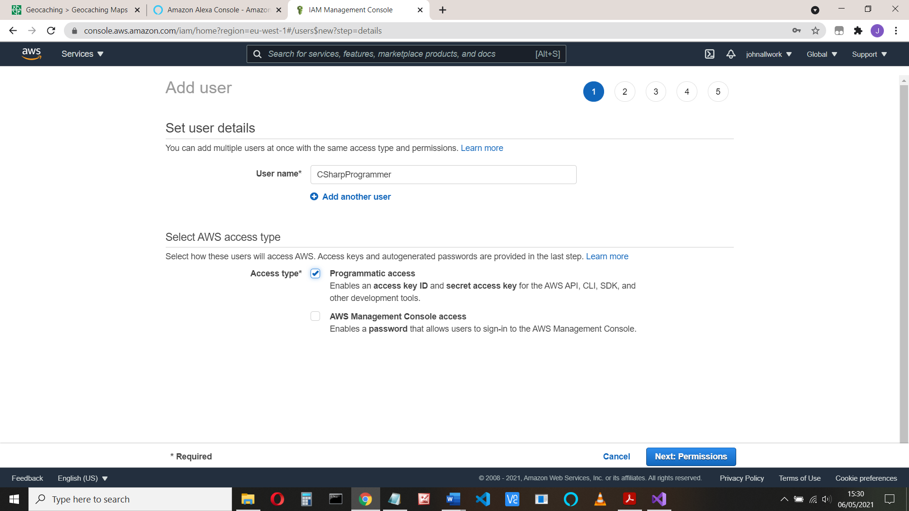

• Attach an administrator or power user policy to the user.

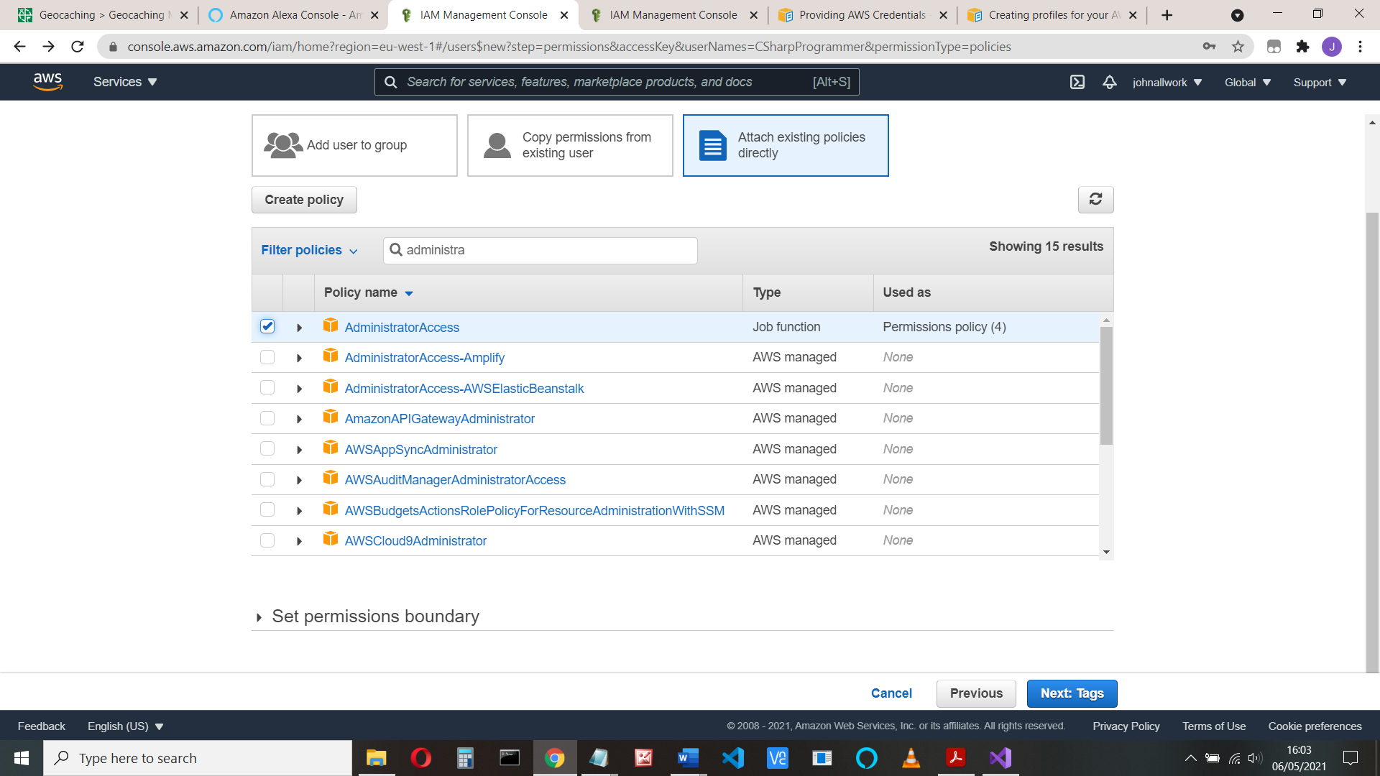

Click Next (tags) and Next (Review) and ‘Create User’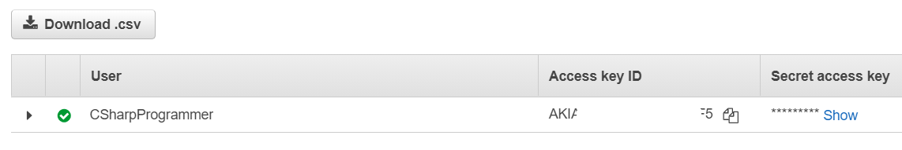

• Copy and paste the credentials (Access Key ID and Secret access key) into the credential fields in Visual Studio, or download the CSV file containing the credentials and Import the credentials

And finally, click save and close

You might also find your files in C:\Users\USERNAME\.aws\credentials

You can close the AWS start screen, The aws-lambda-tools-defaults.json holds the data for the upload

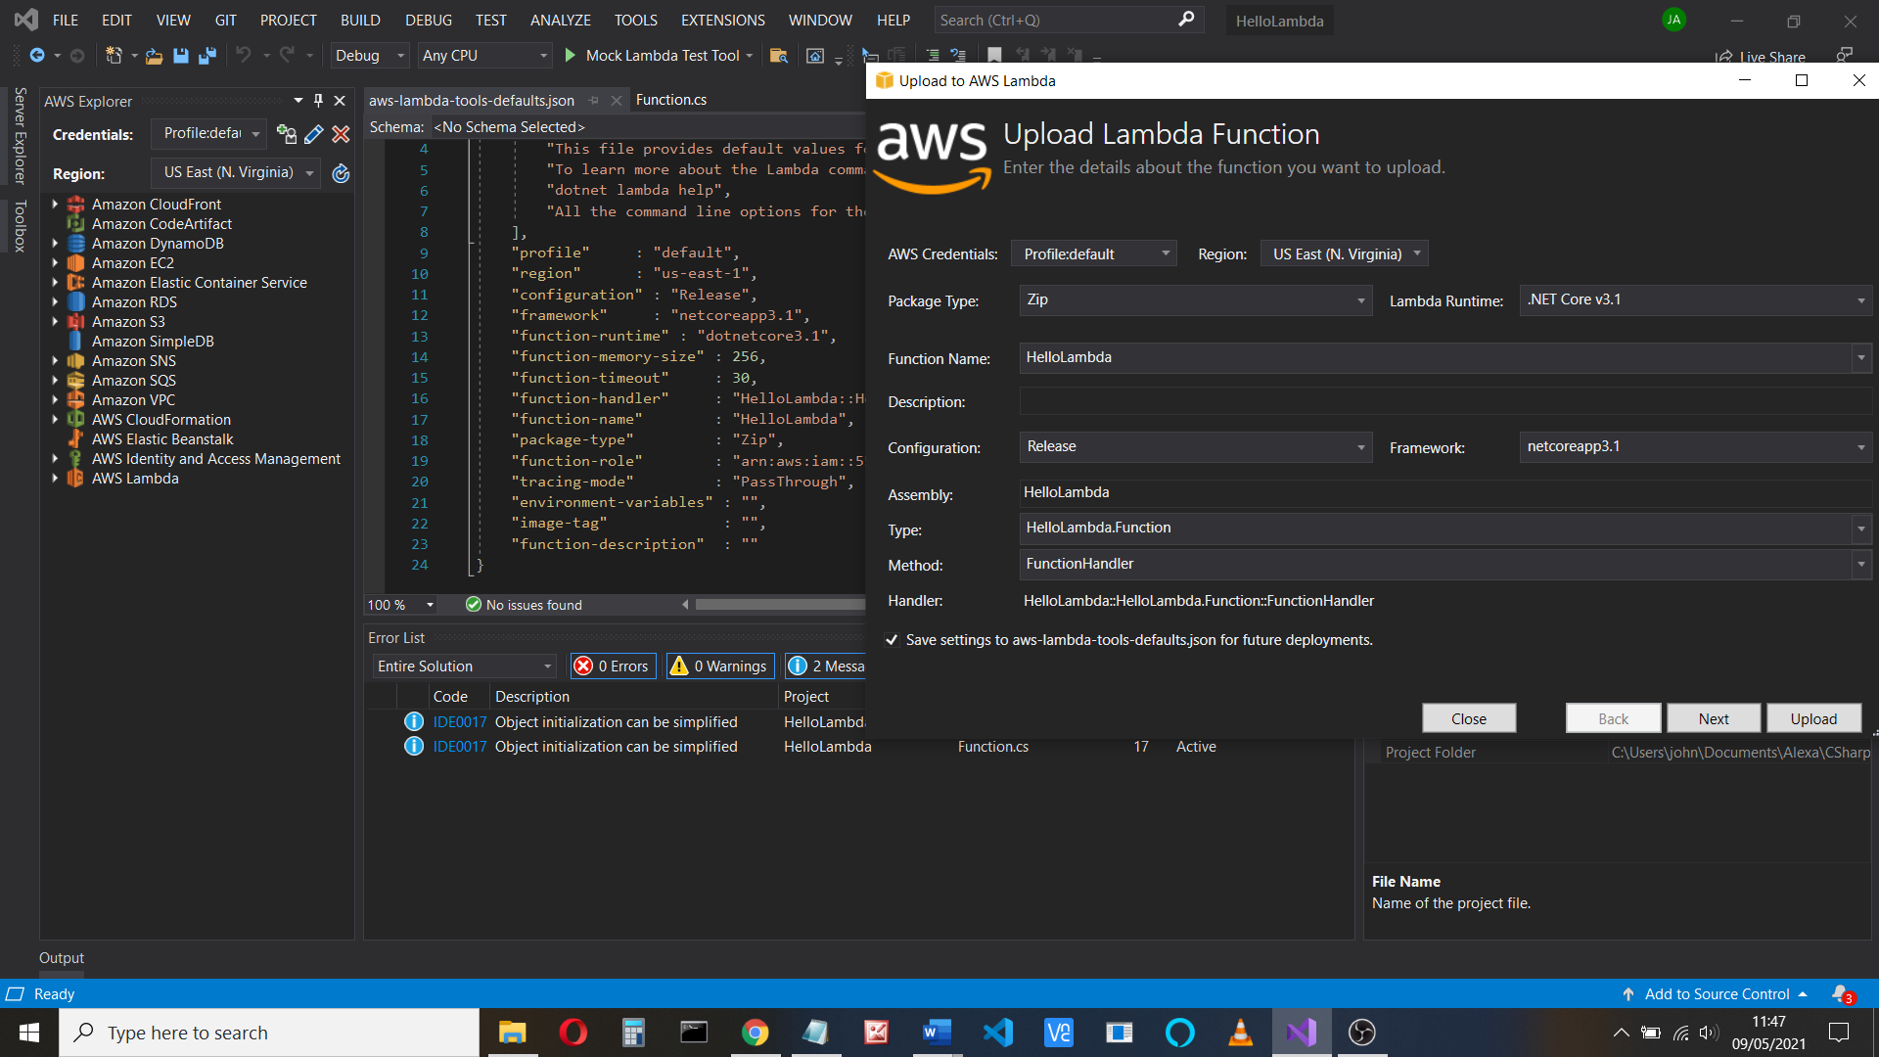

Amazon say if you rename the Assembly, Namespace, Class, or Function in your function code, change them here

Select the function.cs code (this is found in the Solution Explorer) - it has a basic template:

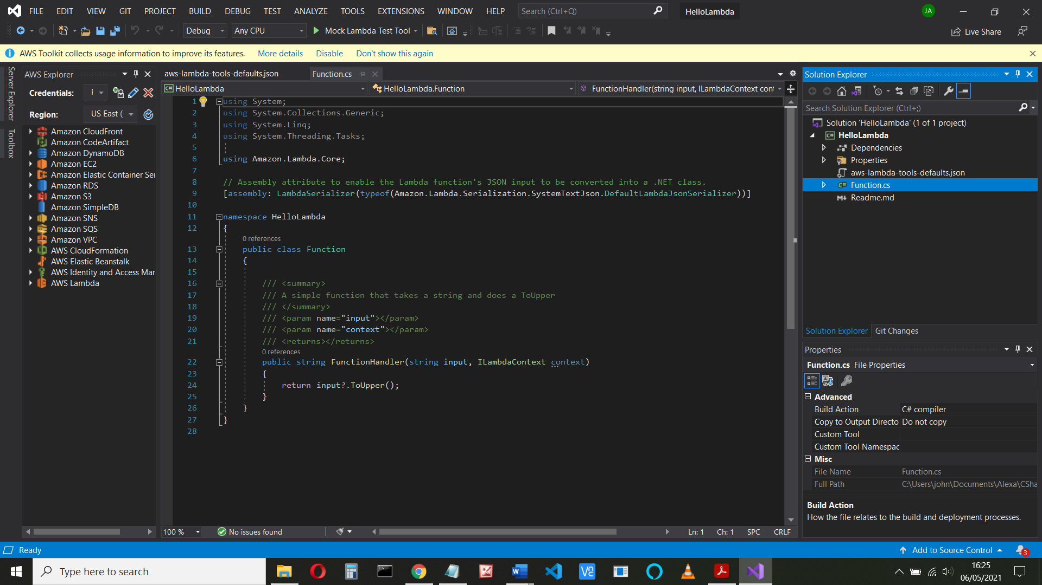

Replace all the code you have with the following. Change the namespace if it’s not called AWSLAmbda1

using Amazon.Lambda.Core;

using Alexa.NET.Response;

using Alexa.NET.Request;

using Alexa.NET.Request.Type;

using Newtonsoft.Json;

// Assembly attribute to enable the Lambda function's JSON input

// to be converted into a .NET class.

[assembly: LambdaSerializer(typeof(Amazon.Lambda.Serialization.Json.JsonSerializer))]

**namespace AWSLambda1**

{

public class Function

{

public SkillResponse FunctionHandler(SkillRequest input, ILambdaContext context)

{

SkillResponse response = new SkillResponse();

response.Response = new ResponseBody();

response.Response.ShouldEndSession = false;

IOutputSpeech innerResponse = null;

var log = context.Logger;

log.LogLine($"Skill Request Object:");

log.LogLine(JsonConvert.SerializeObject(input));

if (input.GetRequestType() == typeof(LaunchRequest))

{

log.LogLine($"Default LaunchRequest made");

innerResponse = new PlainTextOutputSpeech();

(innerResponse as PlainTextOutputSpeech).Text = "Launch Request";

}

else if (input.GetRequestType() == typeof(IntentRequest))

{

var intentRequest = (IntentRequest)input.Request;

switch (intentRequest.Intent.Name)

{

case "AMAZON.CancelIntent":

log.LogLine($"AMAZON.CancelIntent: send StopMessage");

innerResponse = new PlainTextOutputSpeech();

(innerResponse as PlainTextOutputSpeech).Text = "Cancelled";

response.Response.ShouldEndSession = true;

break;

case "AMAZON.StopIntent":

log.LogLine($"AMAZON.StopIntent: send StopMessage");

innerResponse = new PlainTextOutputSpeech();

(innerResponse as PlainTextOutputSpeech).Text = "Stopping";

response.Response.ShouldEndSession = true;

break;

case "AMAZON.HelpIntent":

log.LogLine($"AMAZON.HelpIntent: send HelpMessage");

innerResponse = new PlainTextOutputSpeech();

(innerResponse as PlainTextOutputSpeech).Text = "Help me!";

break;

case "HelloIntent":

log.LogLine($"Say Hello");

innerResponse = new PlainTextOutputSpeech();

(innerResponse as PlainTextOutputSpeech).Text = "Hello Intent";

break;

default:

log.LogLine($"Unknown intent: " + intentRequest.Intent.Name);

innerResponse = new PlainTextOutputSpeech();

(innerResponse as PlainTextOutputSpeech).Text = "Unknown Intent";

break;

}

}

response.Response.OutputSpeech = innerResponse;

response.Version = "1.0";

log.LogLine($"Skill Response Object...");

log.LogLine(JsonConvert.SerializeObject(response));

return response;

}

}

}

If you called your program something other than AWSLambda1, change that in the namespace (namespace AWSLambda1)

1. **Add libraries**

Click the Project name (“HelloLambda”), right-click packages and select Manage Nuget packages

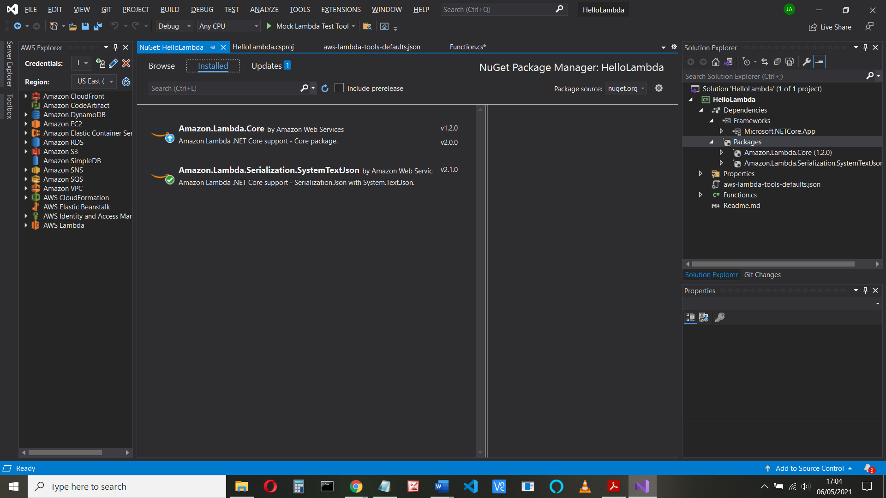

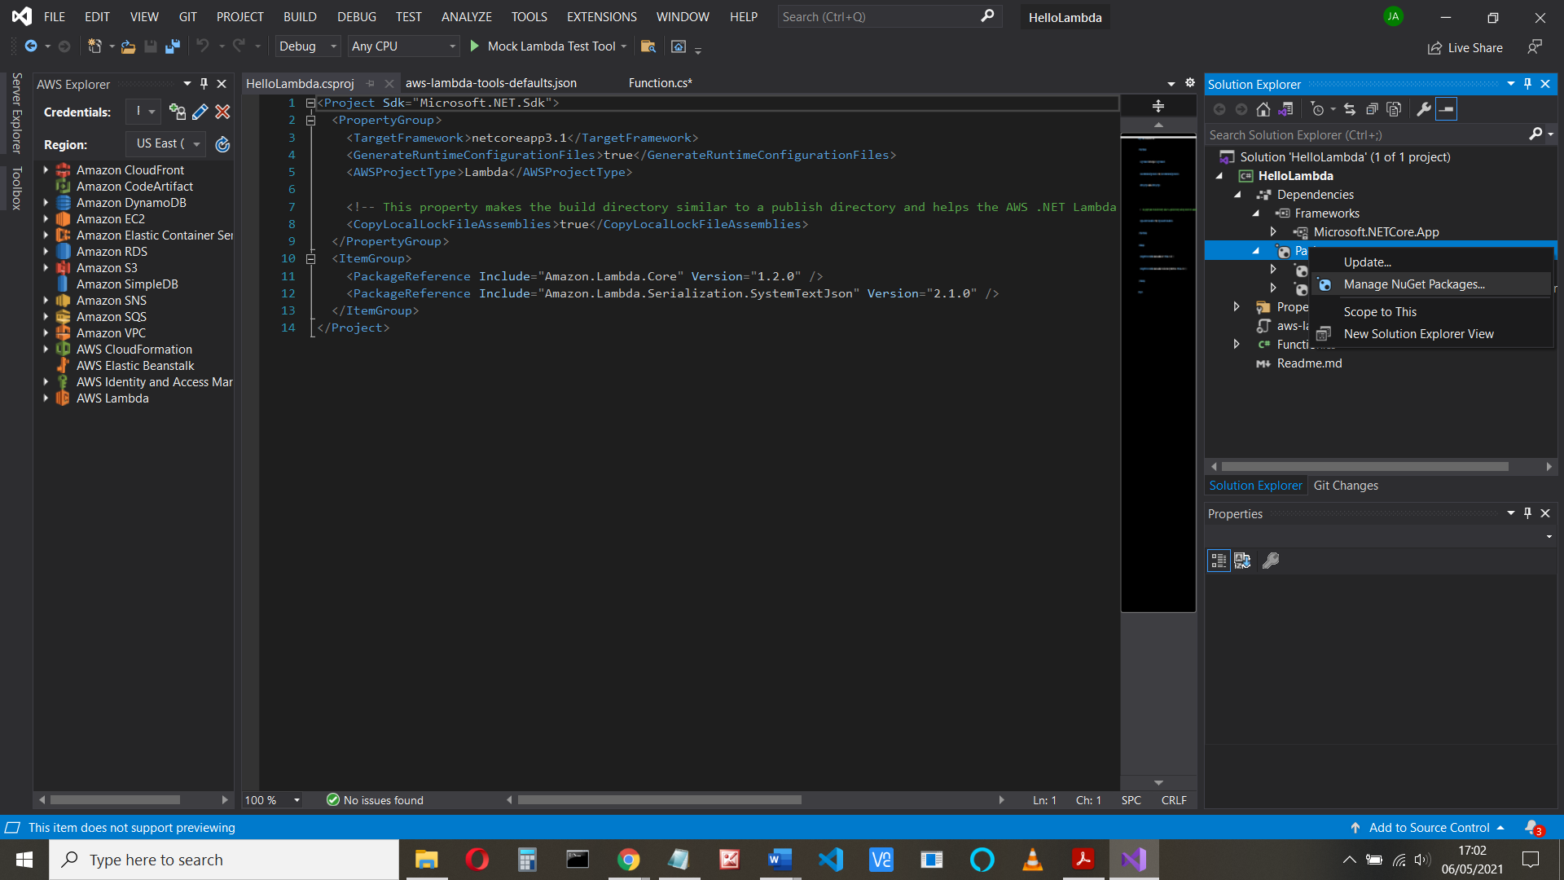

Click Browse, type json.net into the search box and install the **NewtonSoft.Json**

package.

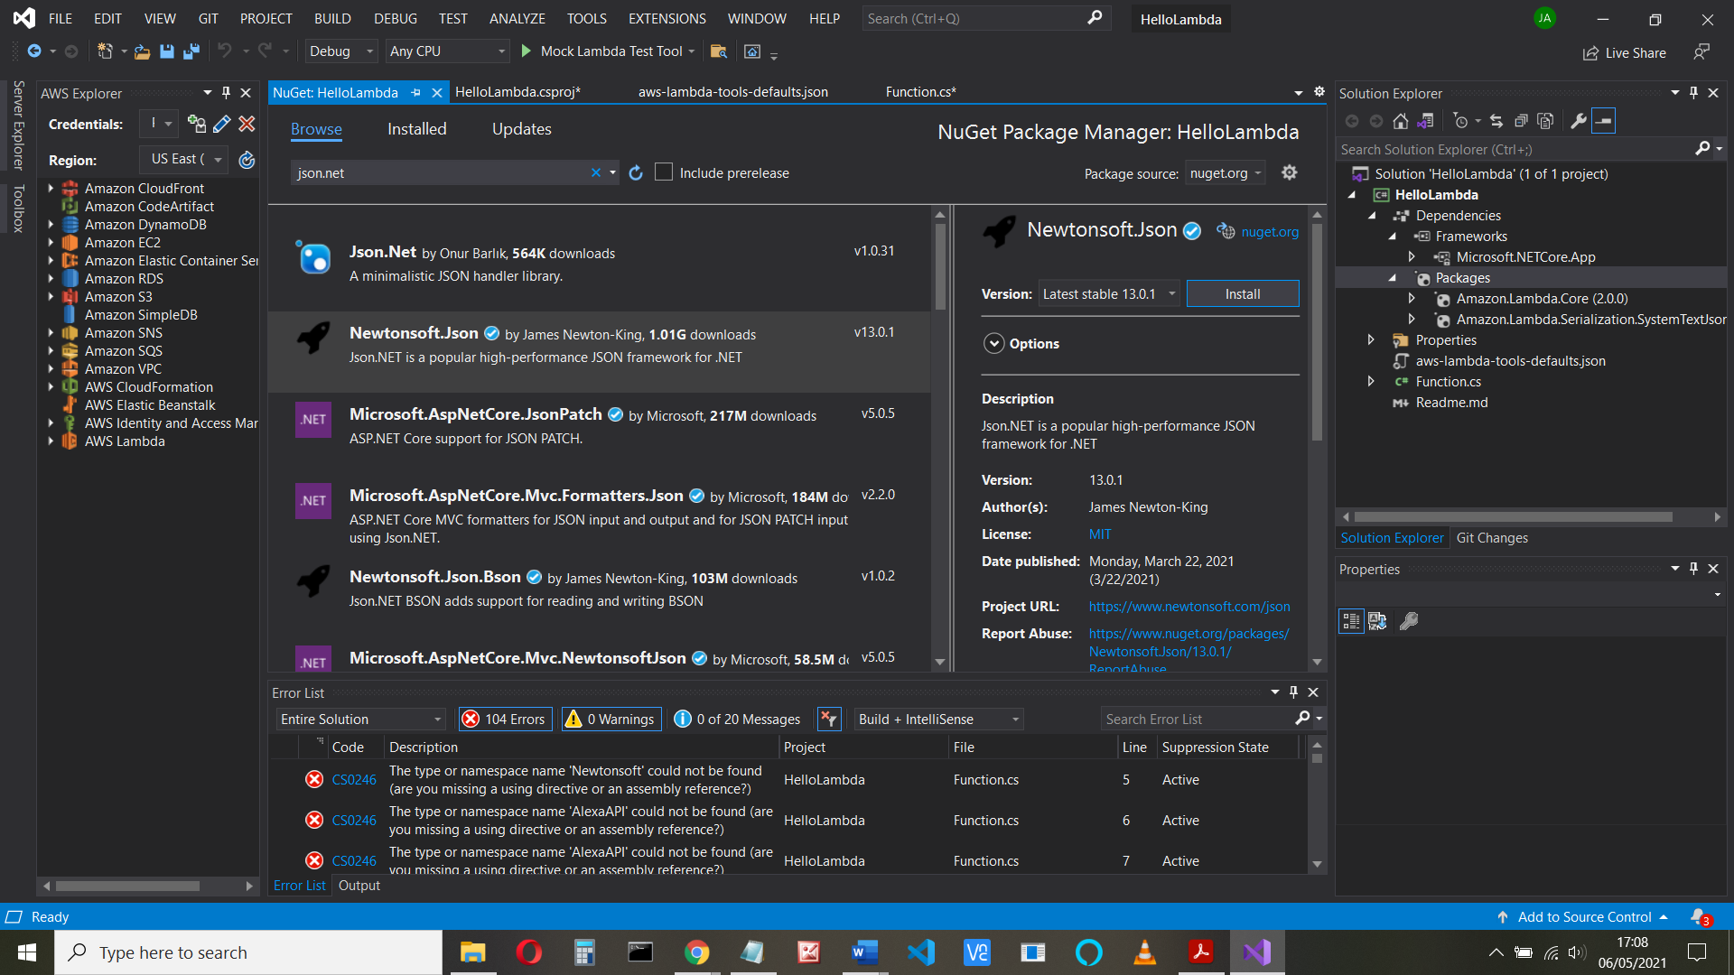

And repeat for **Alexa.NET** by Tim Heuer (tick pre-release and install)

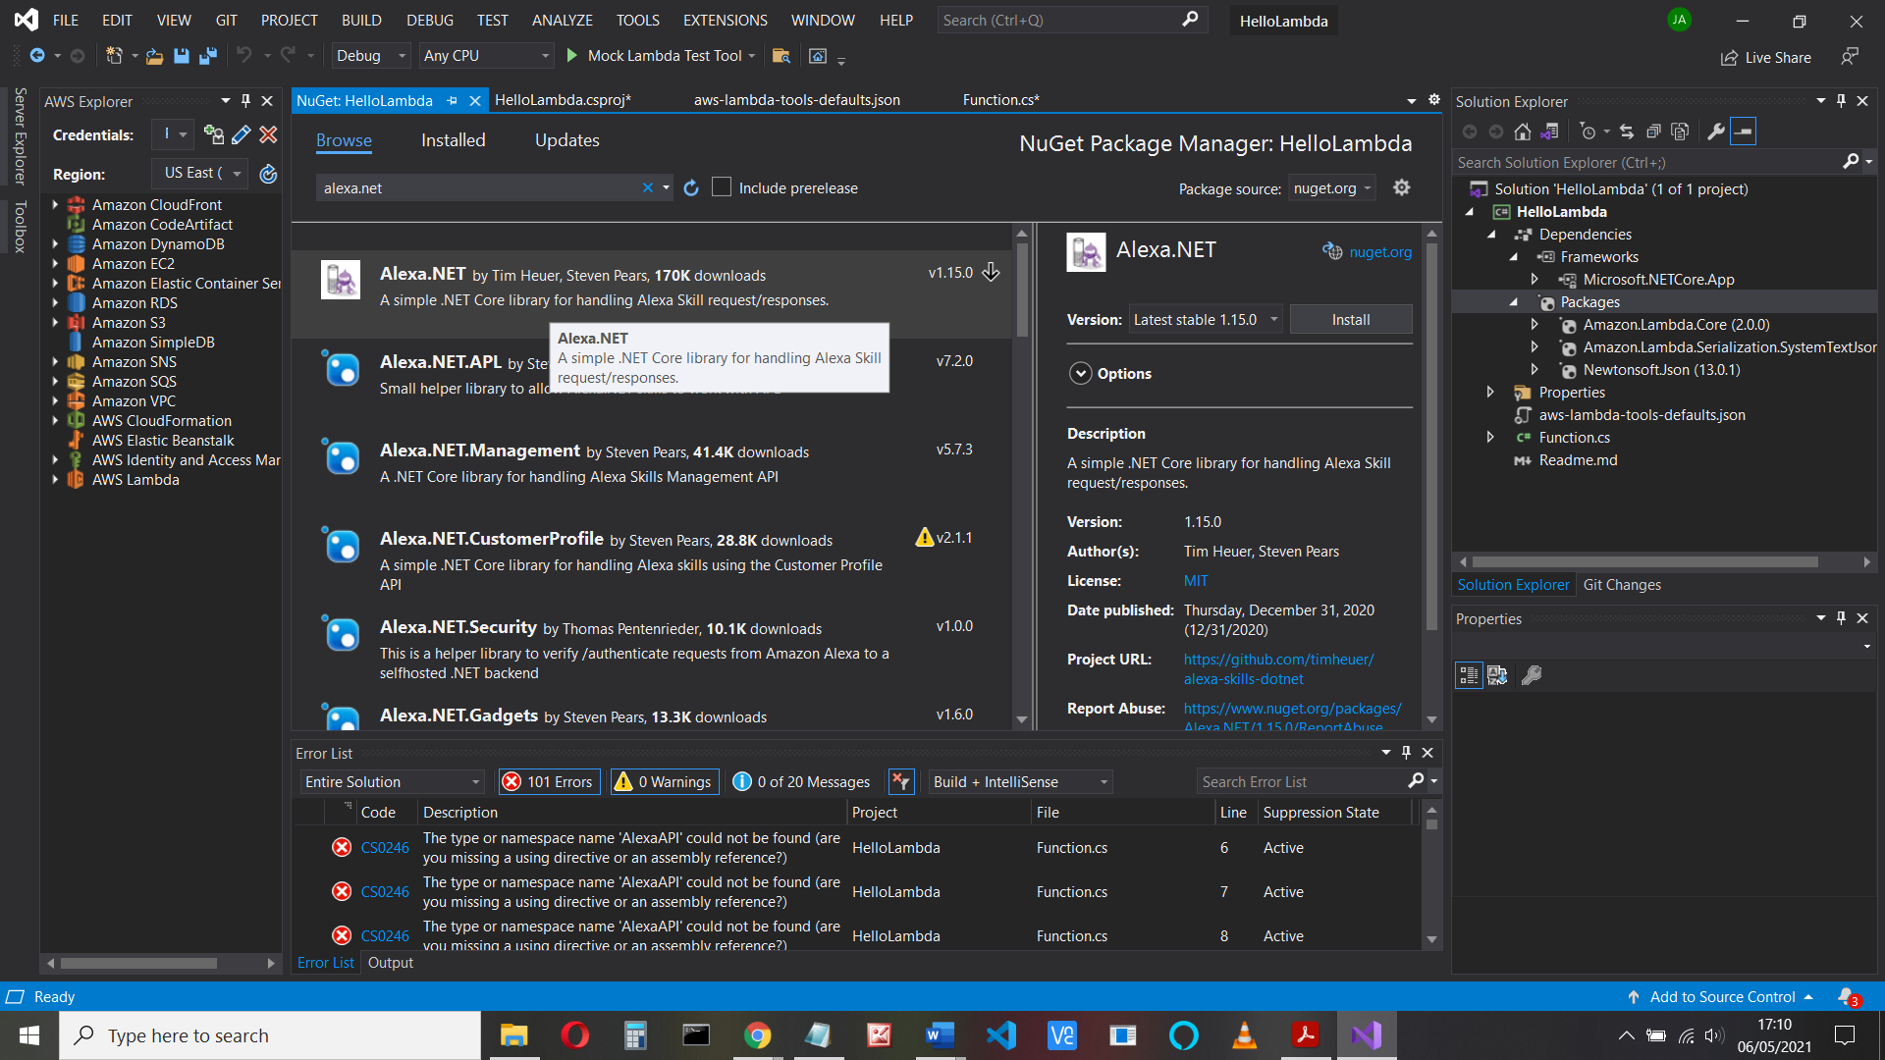

And add **Amazon.Lambda.Serialization.Json**

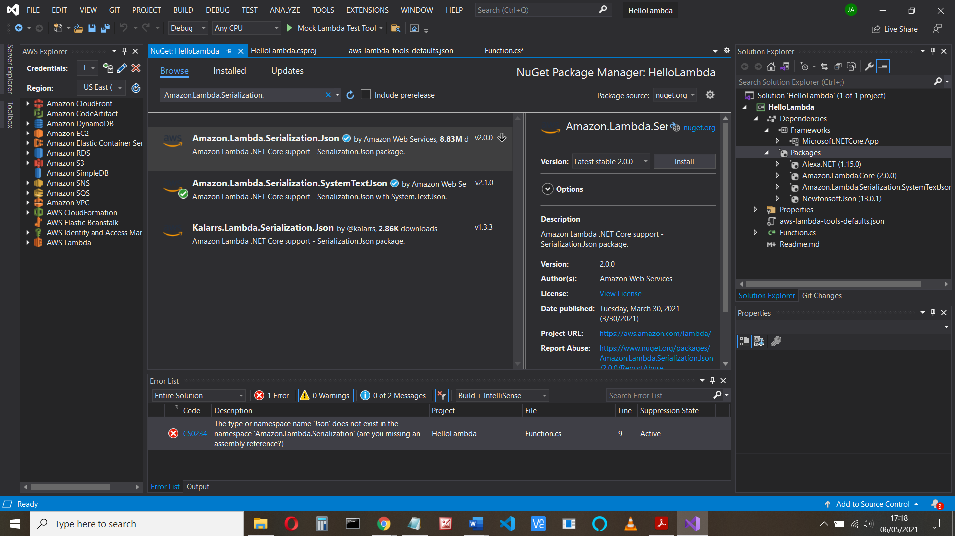

**Check for updates.**

I had to update Amazon Lambda core

I got an error loading this, but just had to update the version.

(Detected package downgrade: Amazon Lambda core from 2.0.00 to 1.2.0. Reference the package directly from the project to select a different version Lambdserialization json > 2.0.0 -> AL core > 2.0)

If you get an error message like:

*The type or namespace name 'Json' does not exist in the namespace 'Amazon.Lambda.Serialization' (are you missing an assembly reference?)*

Check your packages

The Dependencies > Packages I have for this are:

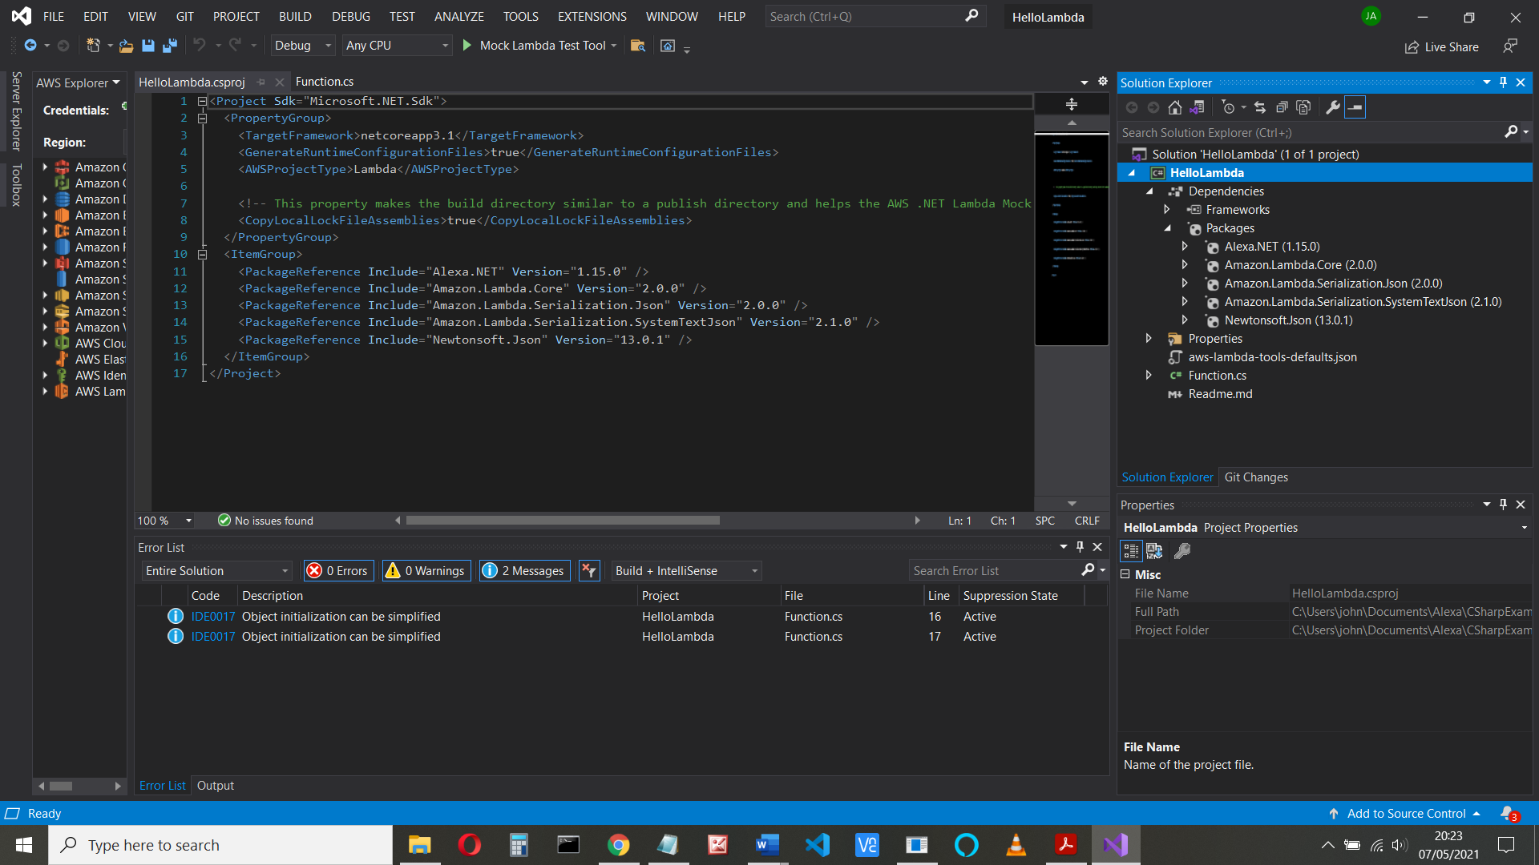

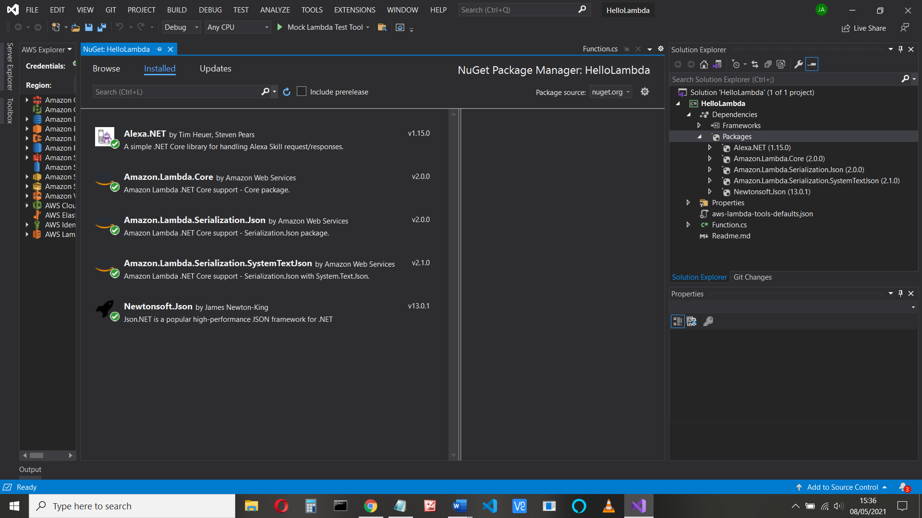

Although the SystemTextJson isn’t needed

**Part 2 – Upload and Test**

We can now upload our code to Amazon’s Lambda service (remember you do have an AWS

account, don’t you?) and compile our code.

Right-click on your project and click Publish to AWS Lambda

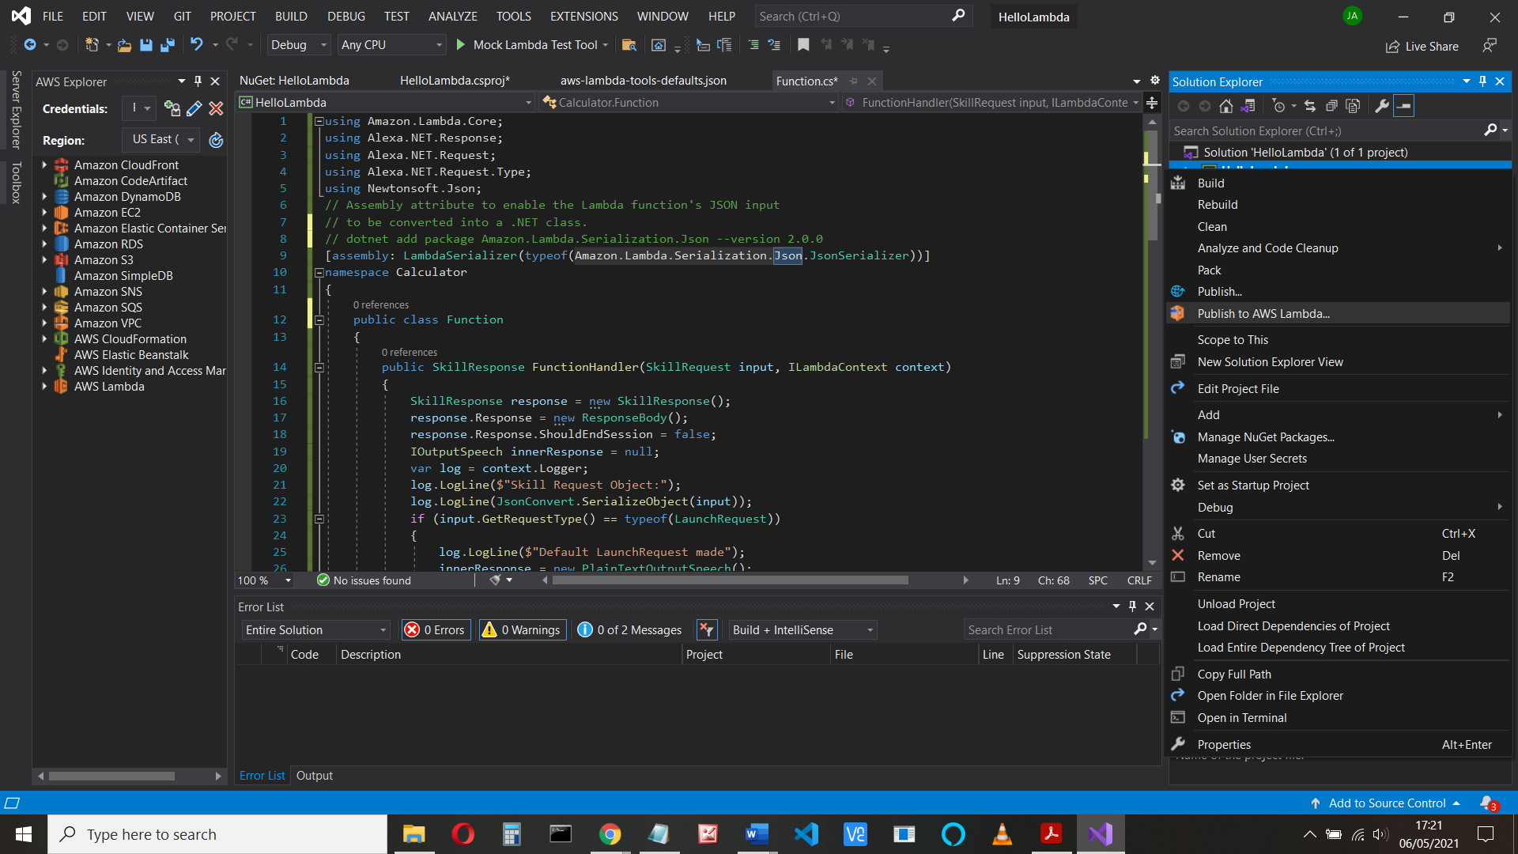

Everything is completed except for the name, so type in Calculator

You might also find it useful to tick the box to remember the settings

In the next screen, for the Role Name select lambda_basic_execution from the drop down

box, and then **Upload**.

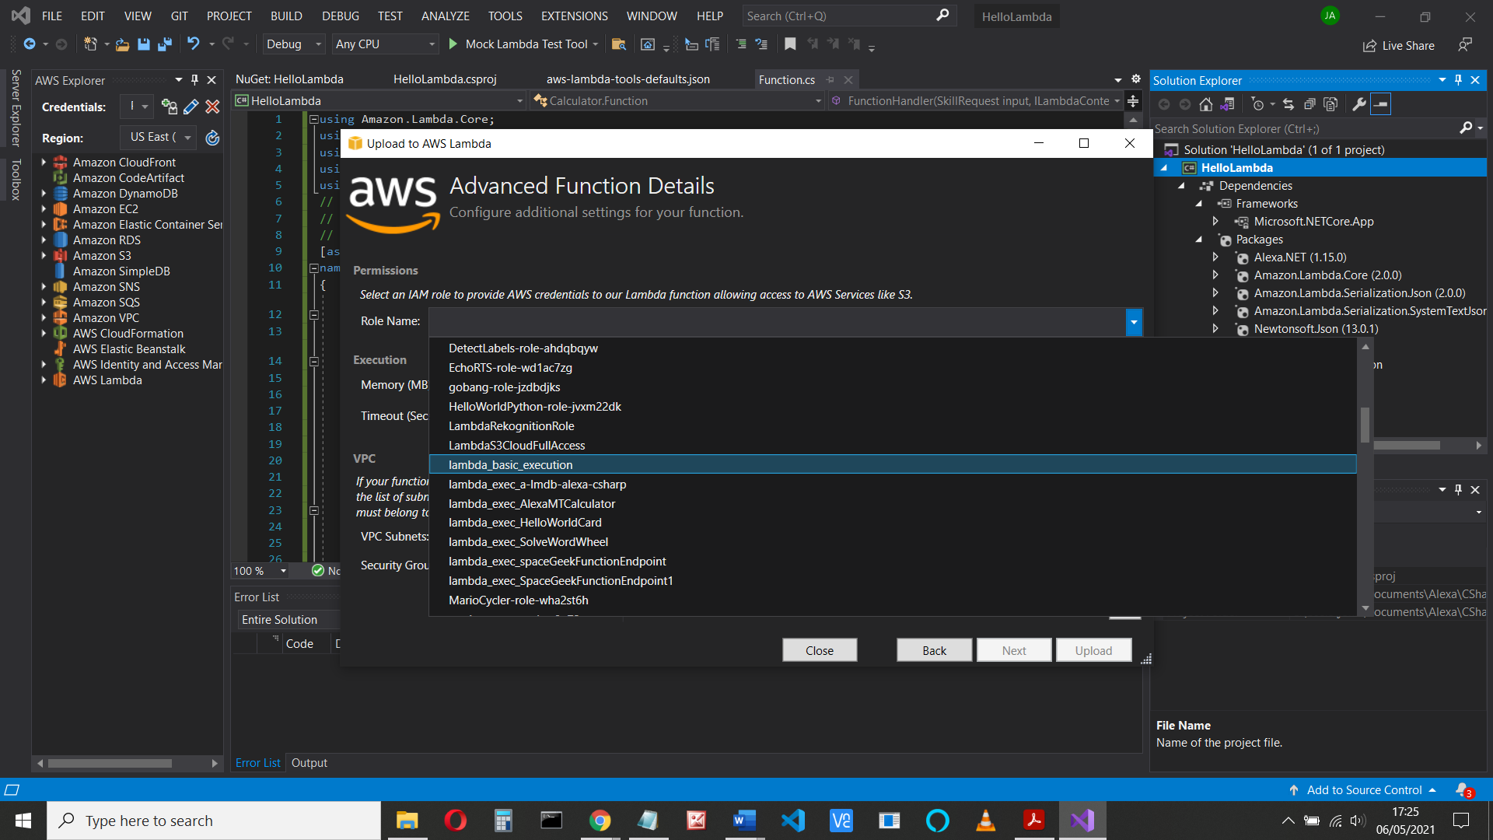

Choose Alexa Start Session from the Example Requests drop down box,

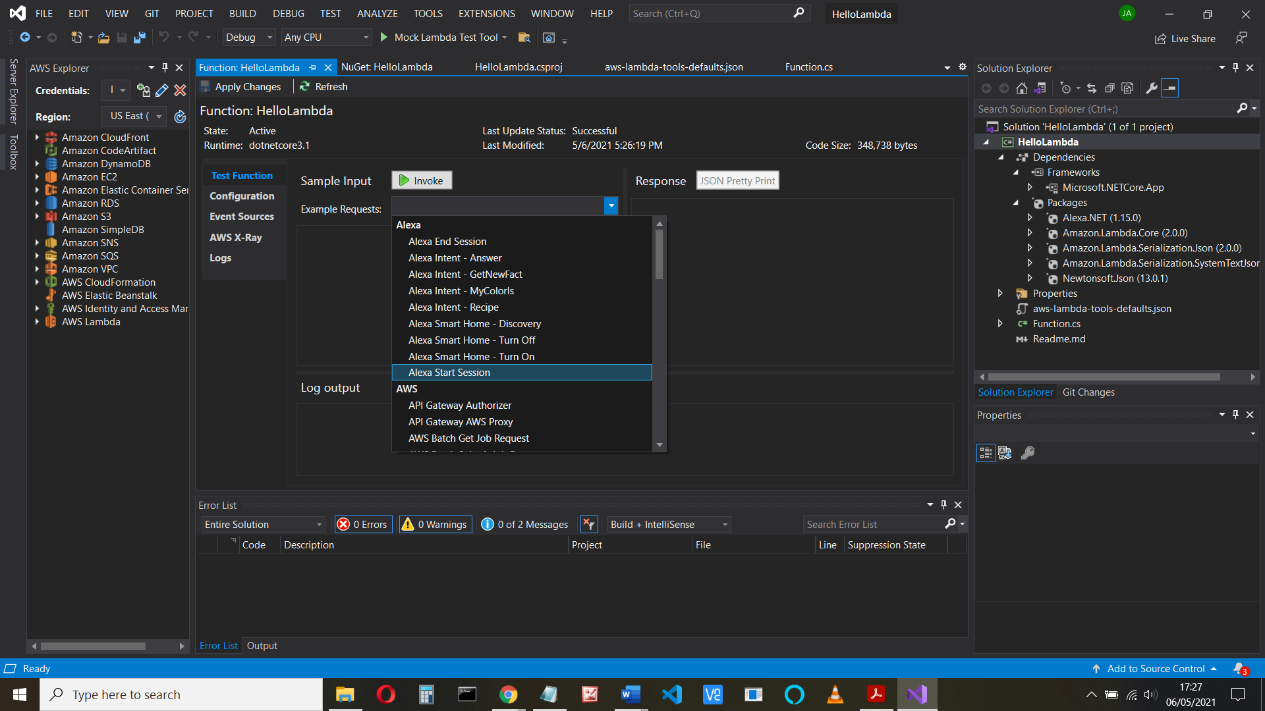

and click Invoke:

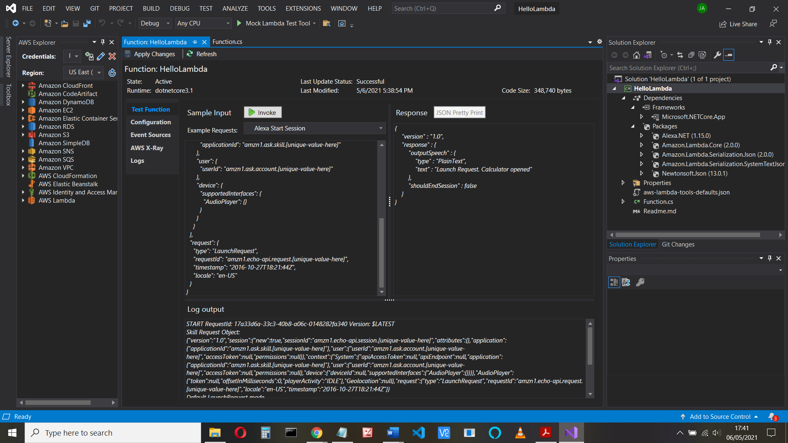

If you get the error

{

"errorType": "LambdaException",

"errorMessage": "Unable to load type 'HelloLambda.Function' from assembly 'HelloLambda'."

}

Check namespace and solution names are the same

**Part 3 – Skill Information and Interaction Model**

Now let’s see if our function is on the AWS site.

Go to AWS console (https://console.aws.amazon.com/ ) and find Lambda > Functions:

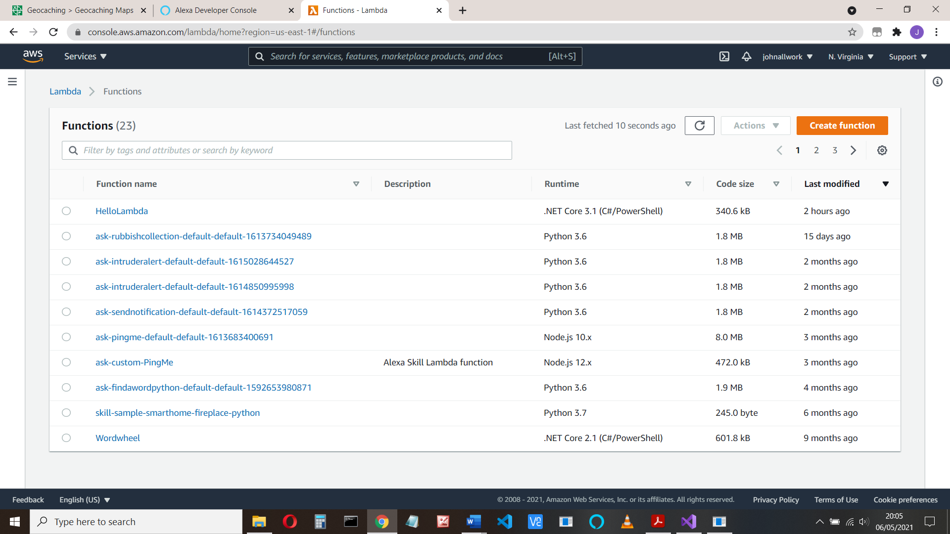

Select your function and copy the ARN (* see later)

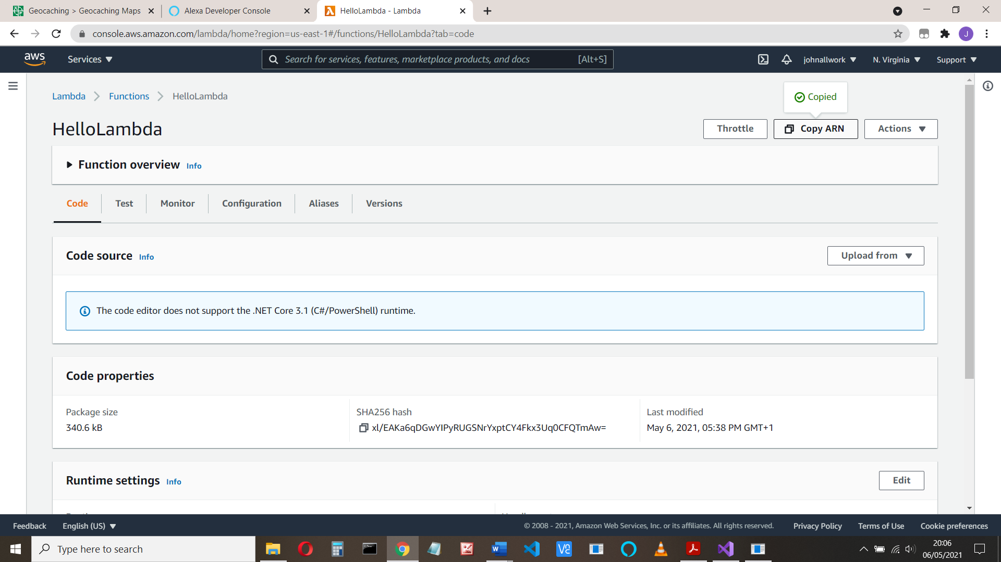 

At this stage, you can run the Test again, as we did in Visual Studio. Click the Test tab:

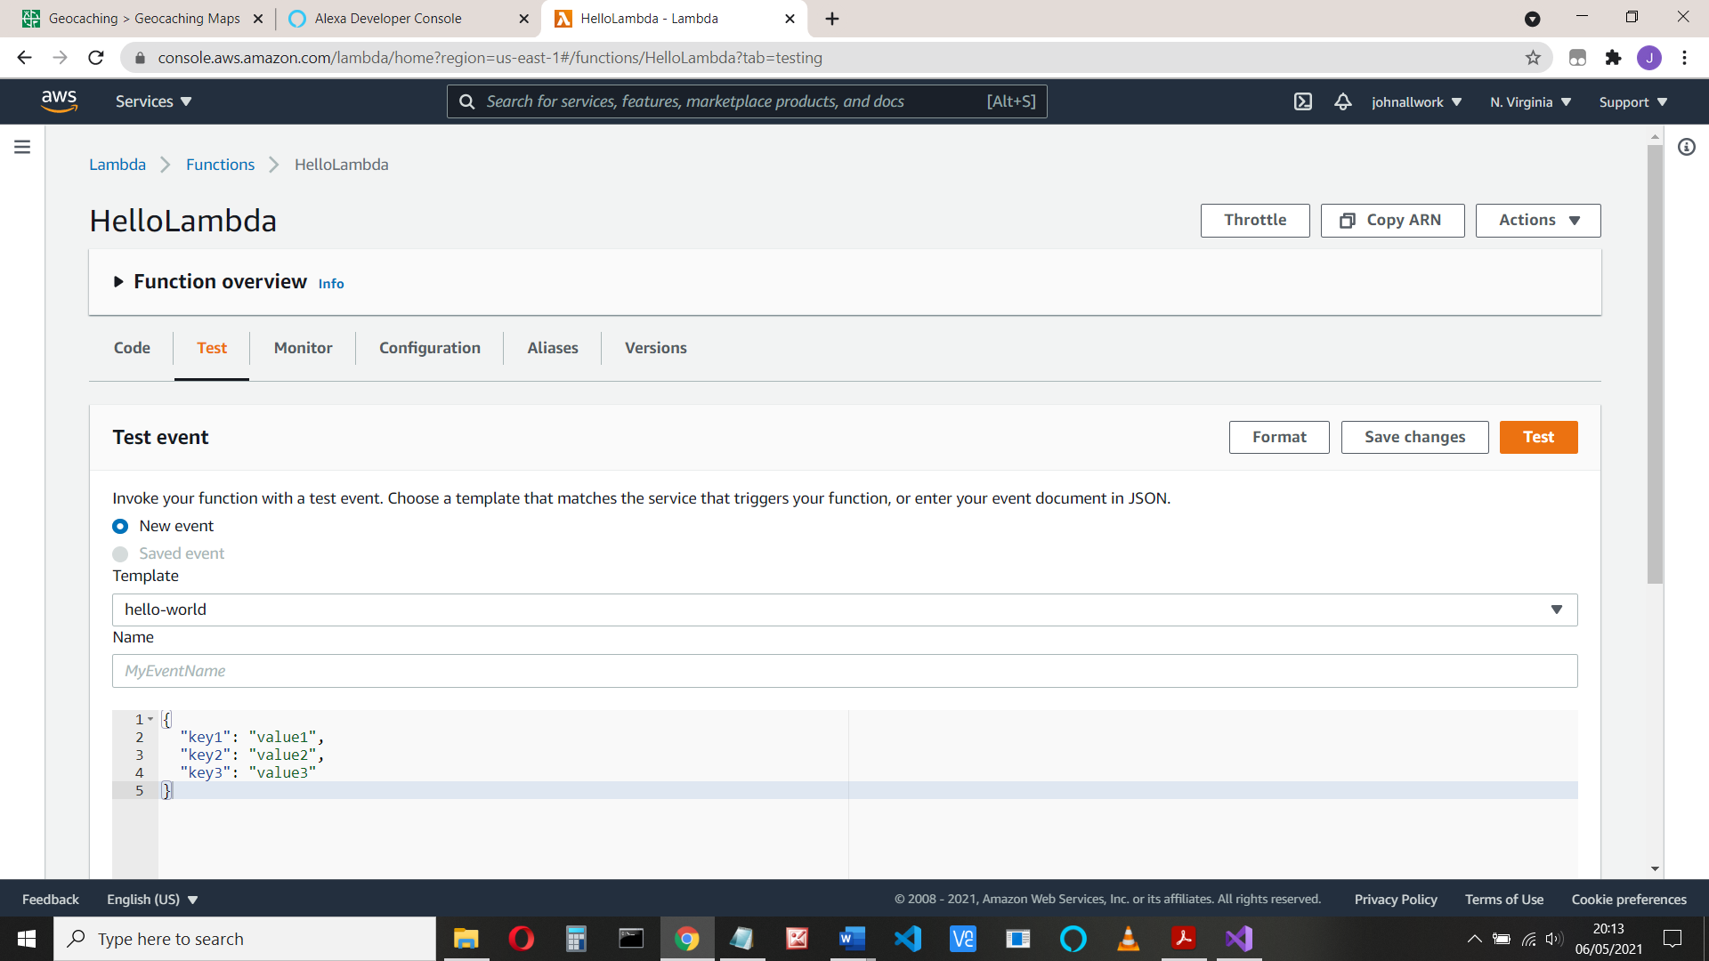

Then from the template drop down box, select Amazon Alexa Start Session

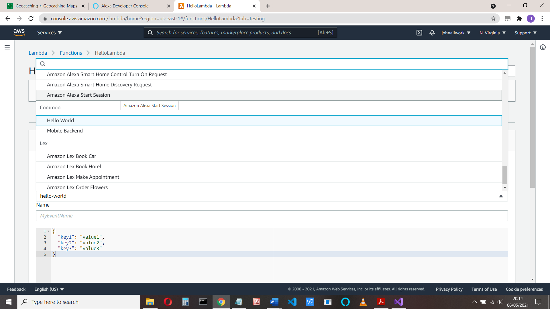

Then click Test. You should get Execution succeeded

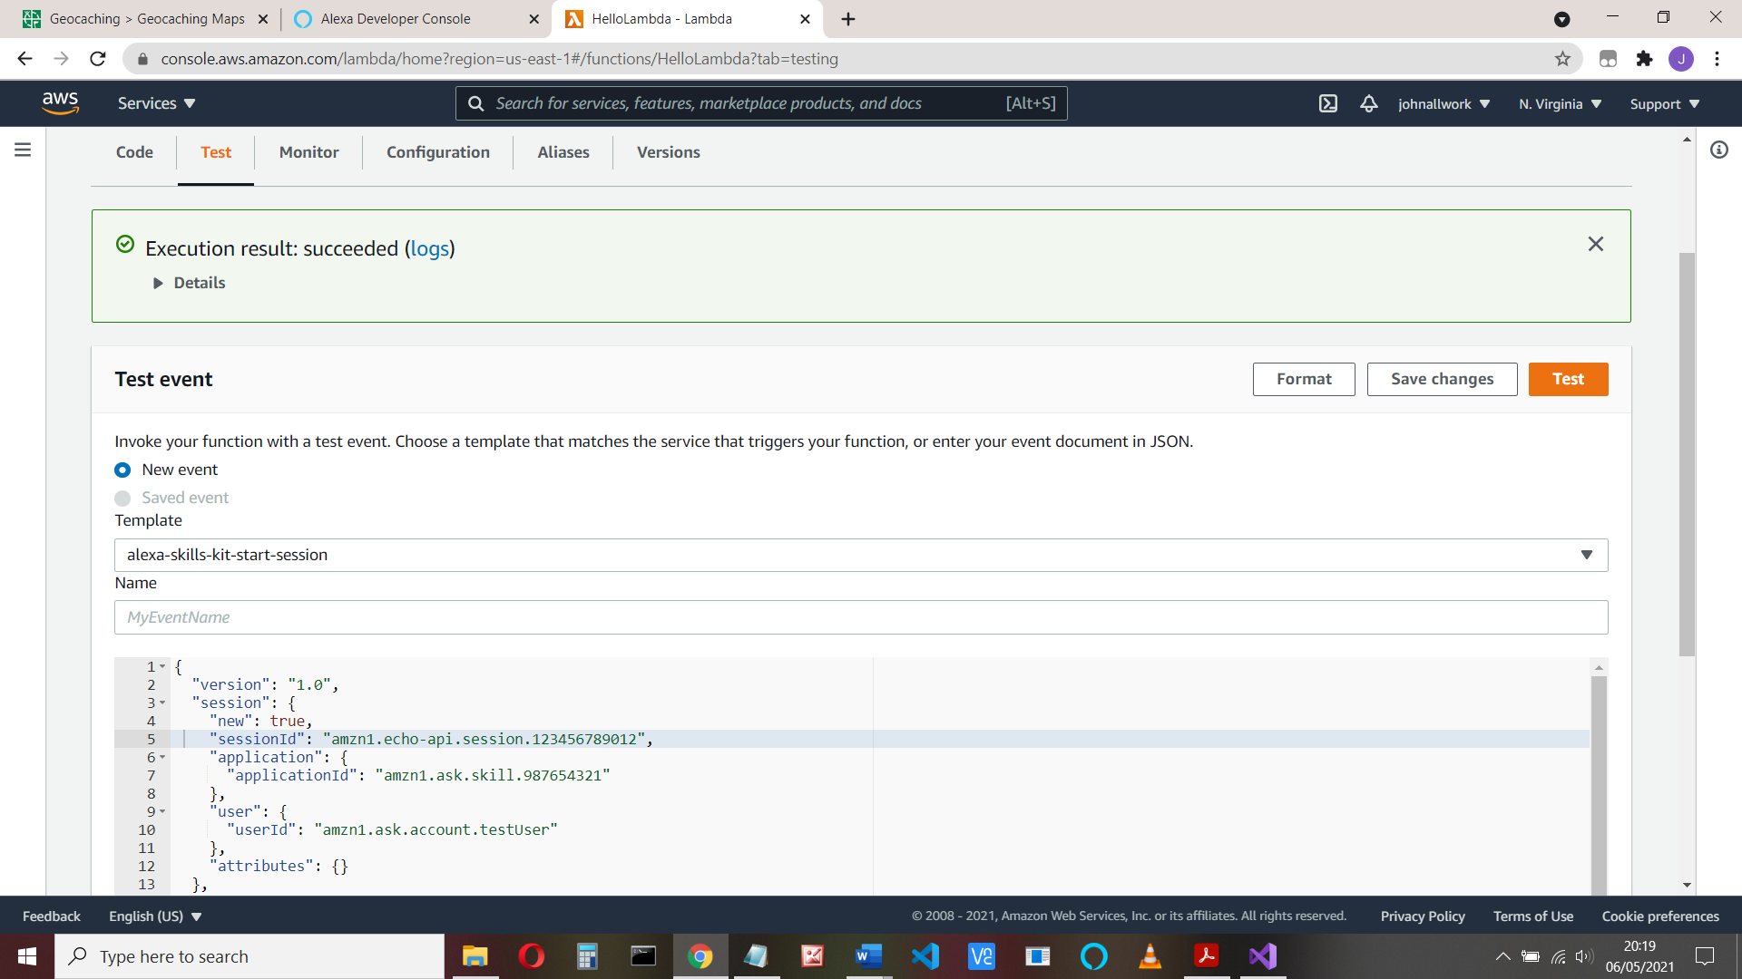

If you click the logs link, you can see the logs from your program in cloudwatch:

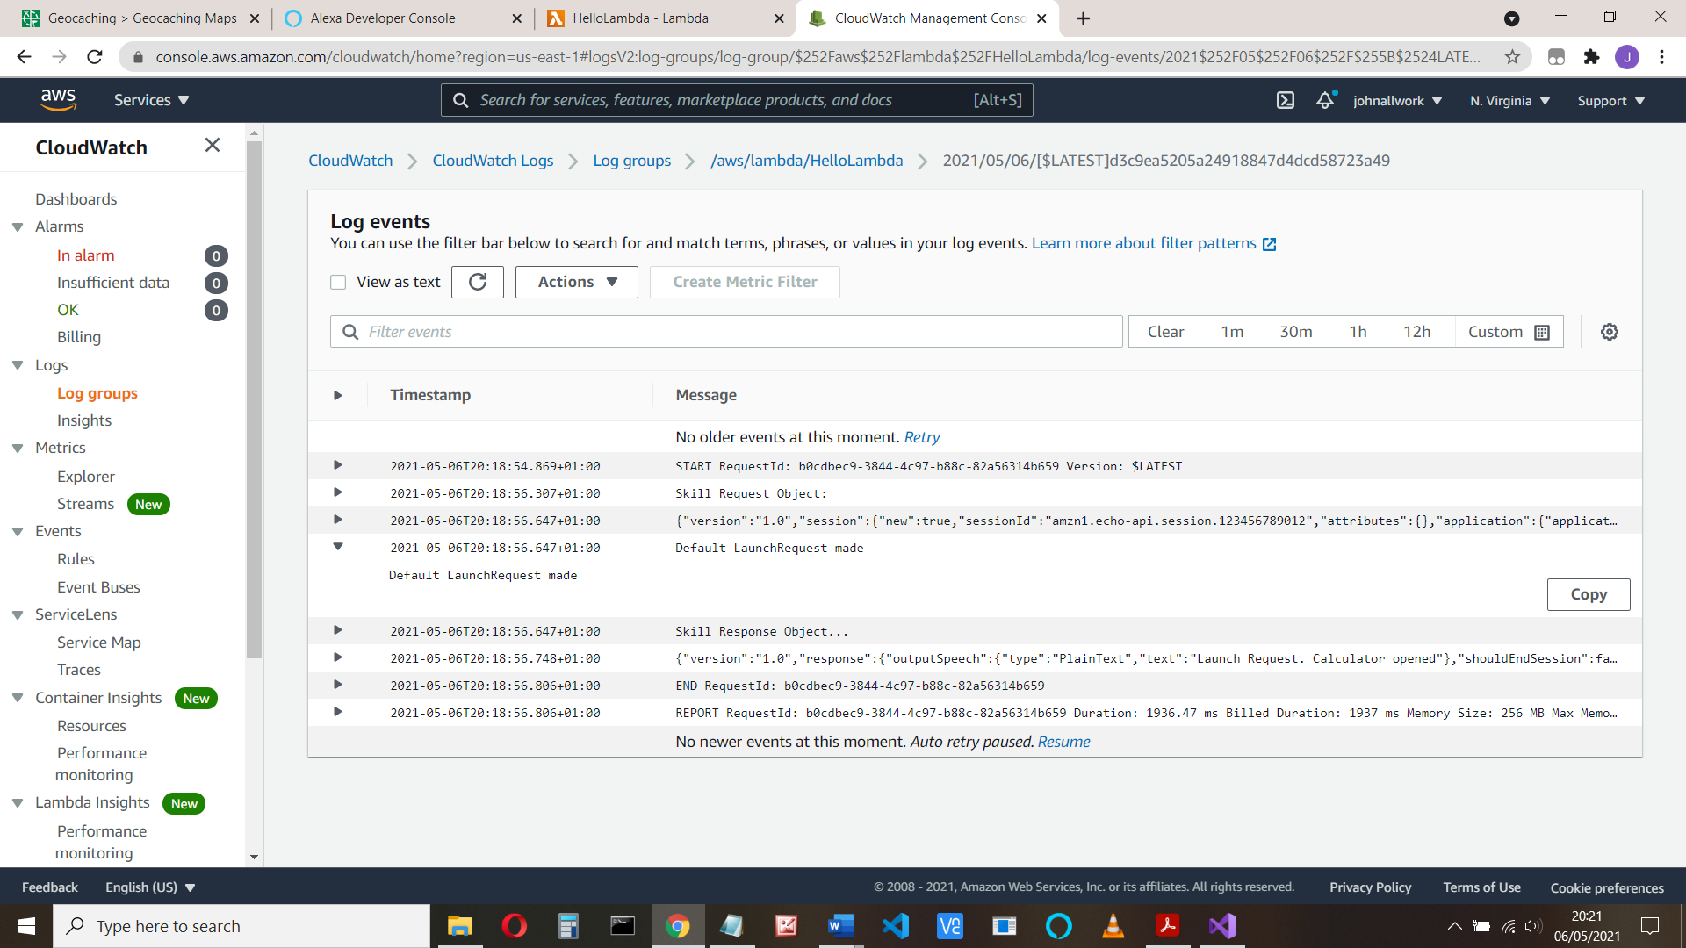

Here we see the output from the code:

log.LogLine($"Default LaunchRequest made");

Link the lambda to our skill

We need to add a trigger to the lambda function. Go to Configuration > Triggers

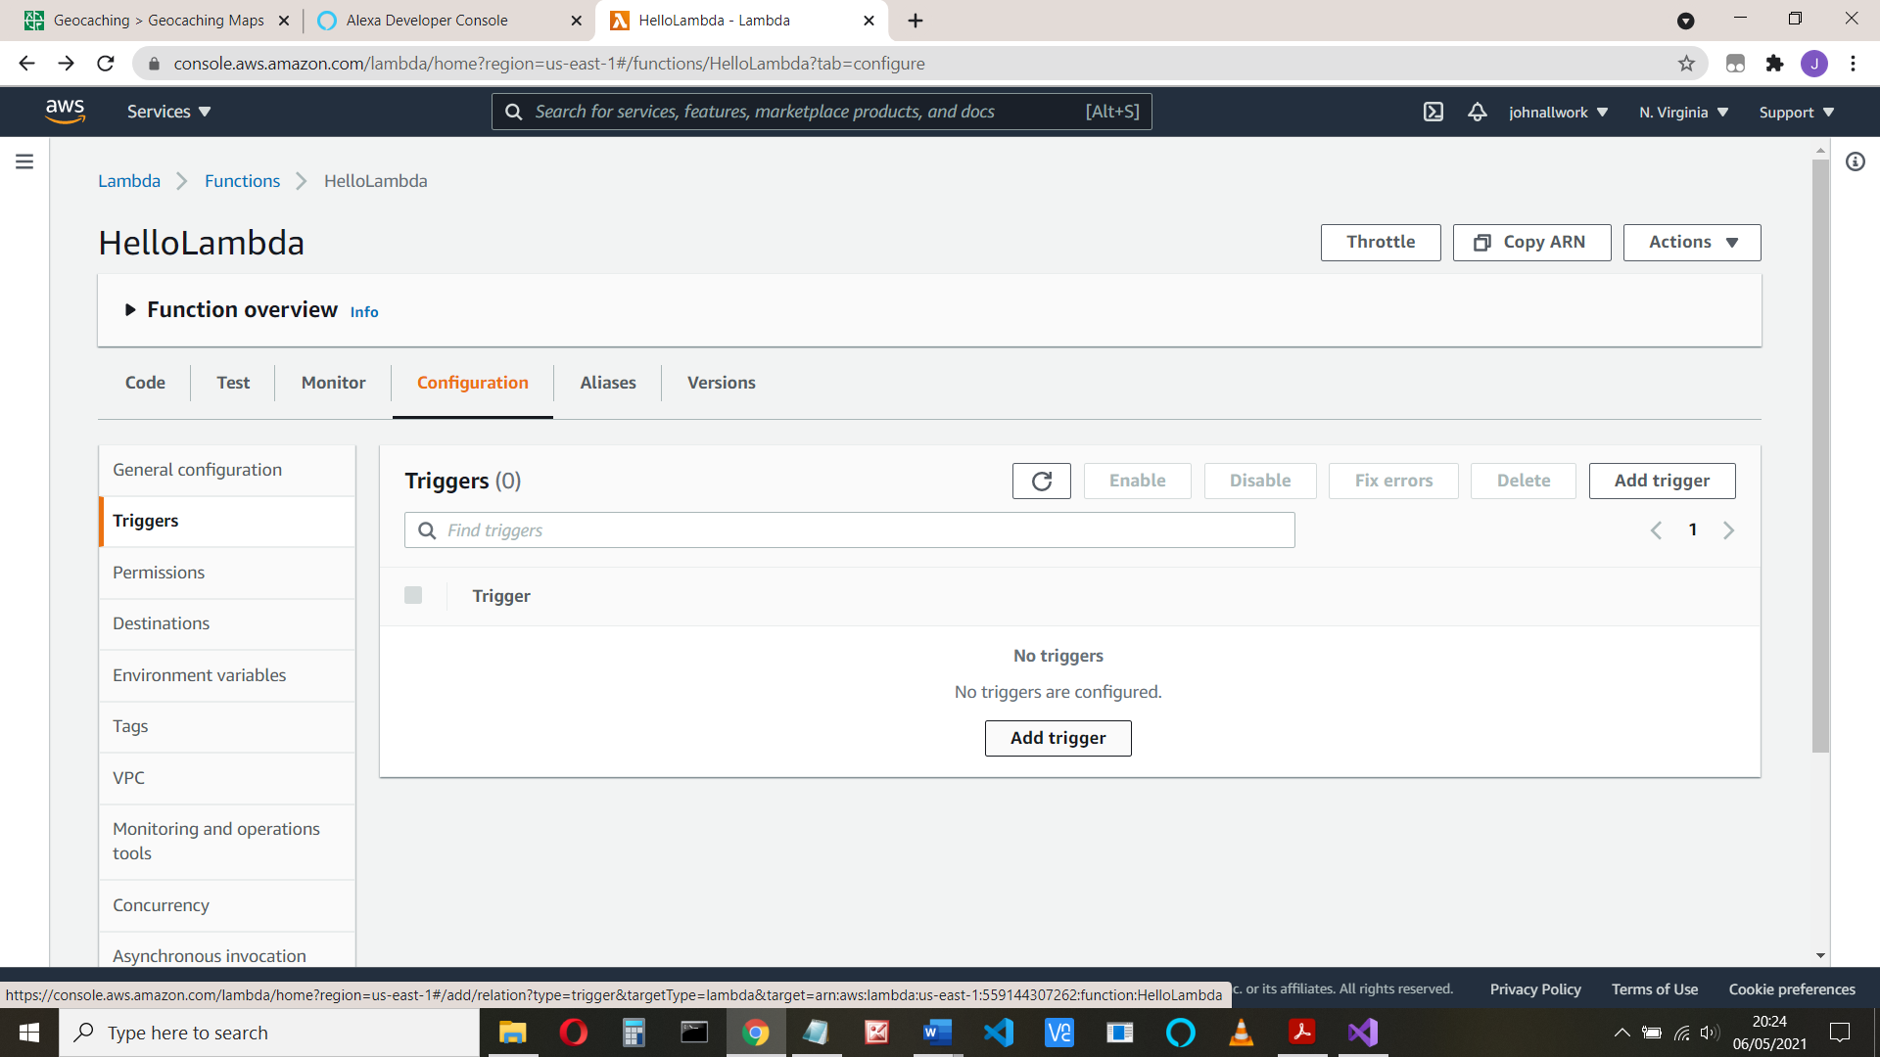

We will choose Alexa Skills kit. But before we can do this, we need the skill ID that comes from the Developer site. That in turn needs the Amazon Resource Number (ARN) – it’s in the top right. If you didn’t do so, make a copy of that now.

Open the developer dashboard (developer.amazon.com)

In the developer console, choose Alexa Skills Kit and Add a new skill. Call it Hello lambda

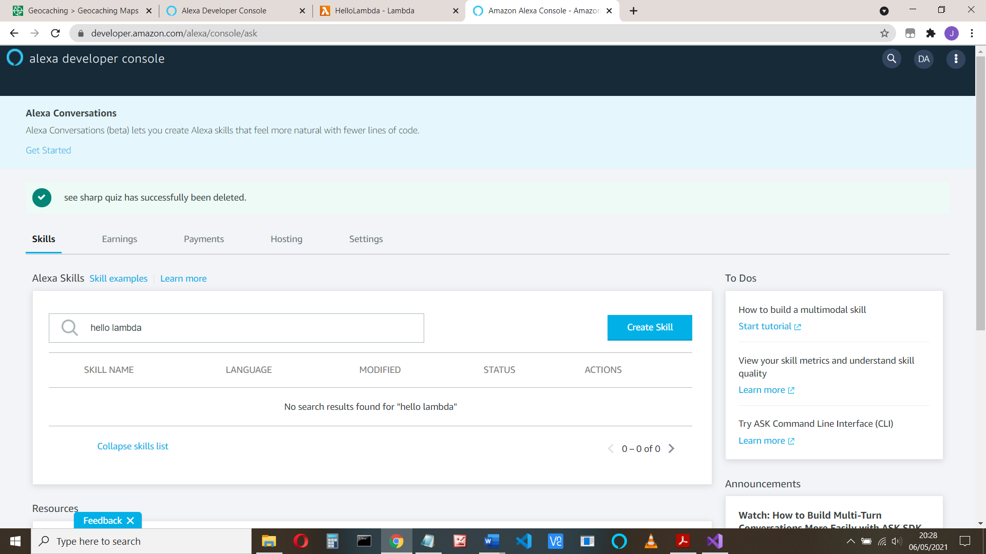

And click Create Skill

Name that skill! (hello lambda)

Choose your local language, custom model and ‘Provision your own’

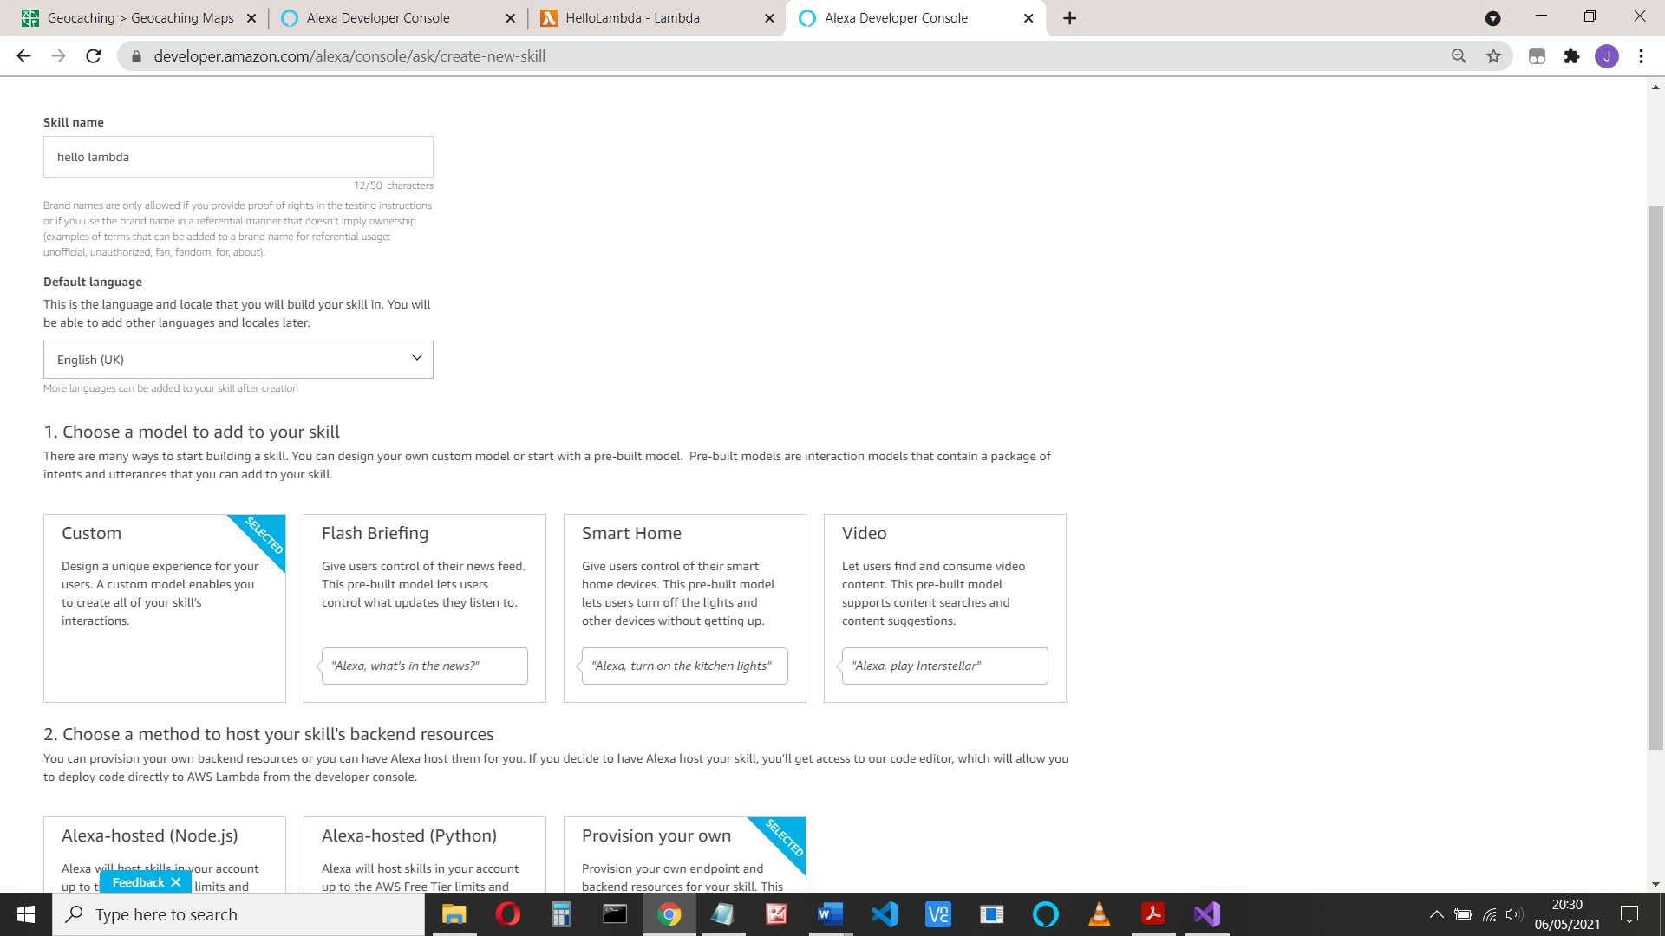

And click create skill, choose Start from Scratch for the template

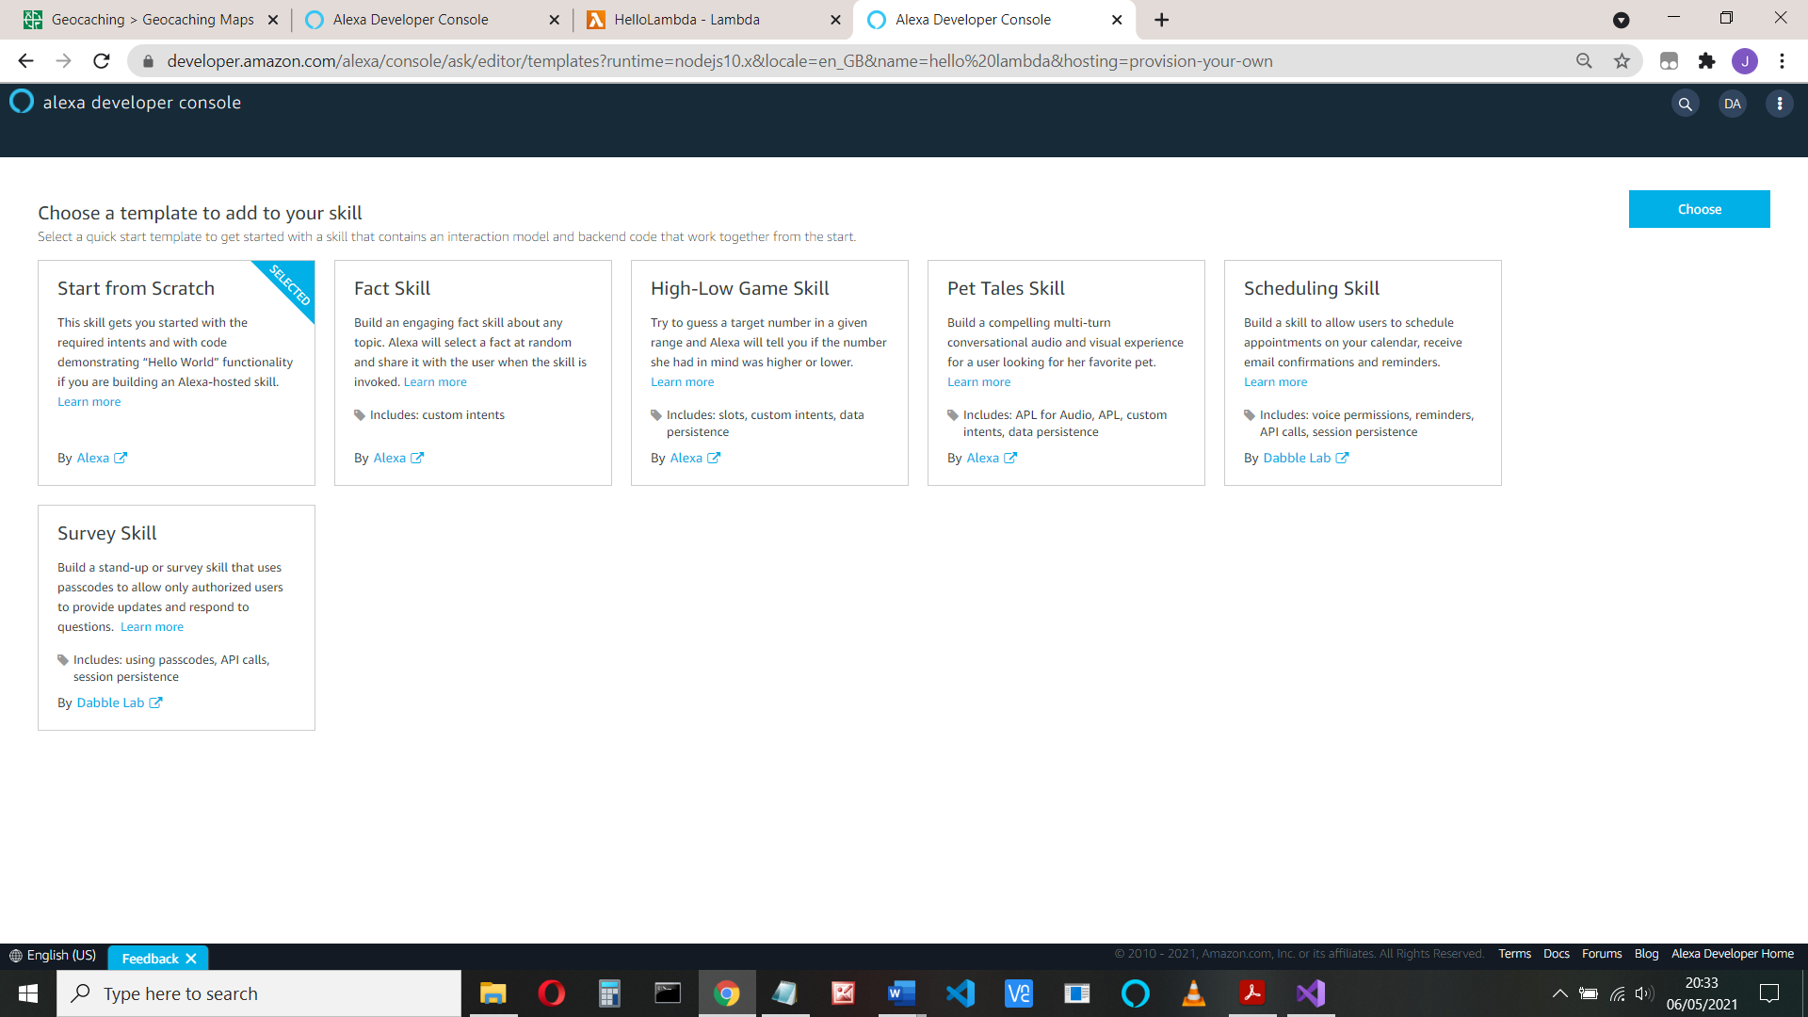

Now select Endpoint and copy the skill ID it begins with amzn1.ask.skill

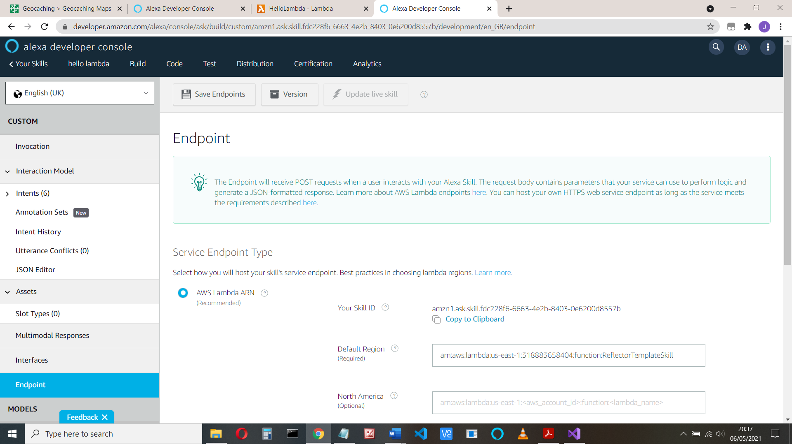

Return to the AWS screen, add the trigger, select Alexa Skill Kit and paste you skill ID

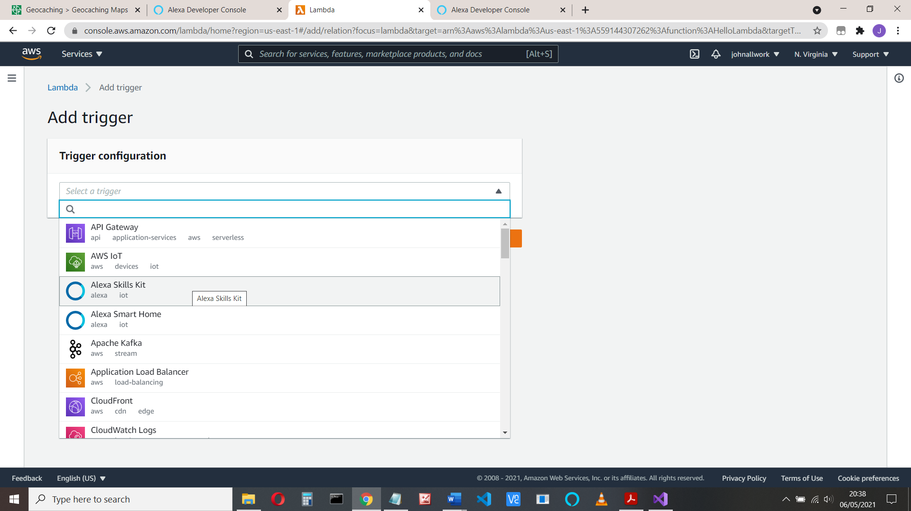

The reason for all that is so when a user uses your skill (says “open hello lambda”) the skill will trigger your C# lambda code, and it will respond.

(You could have other triggers, such as run some code when a photo is uploaded)

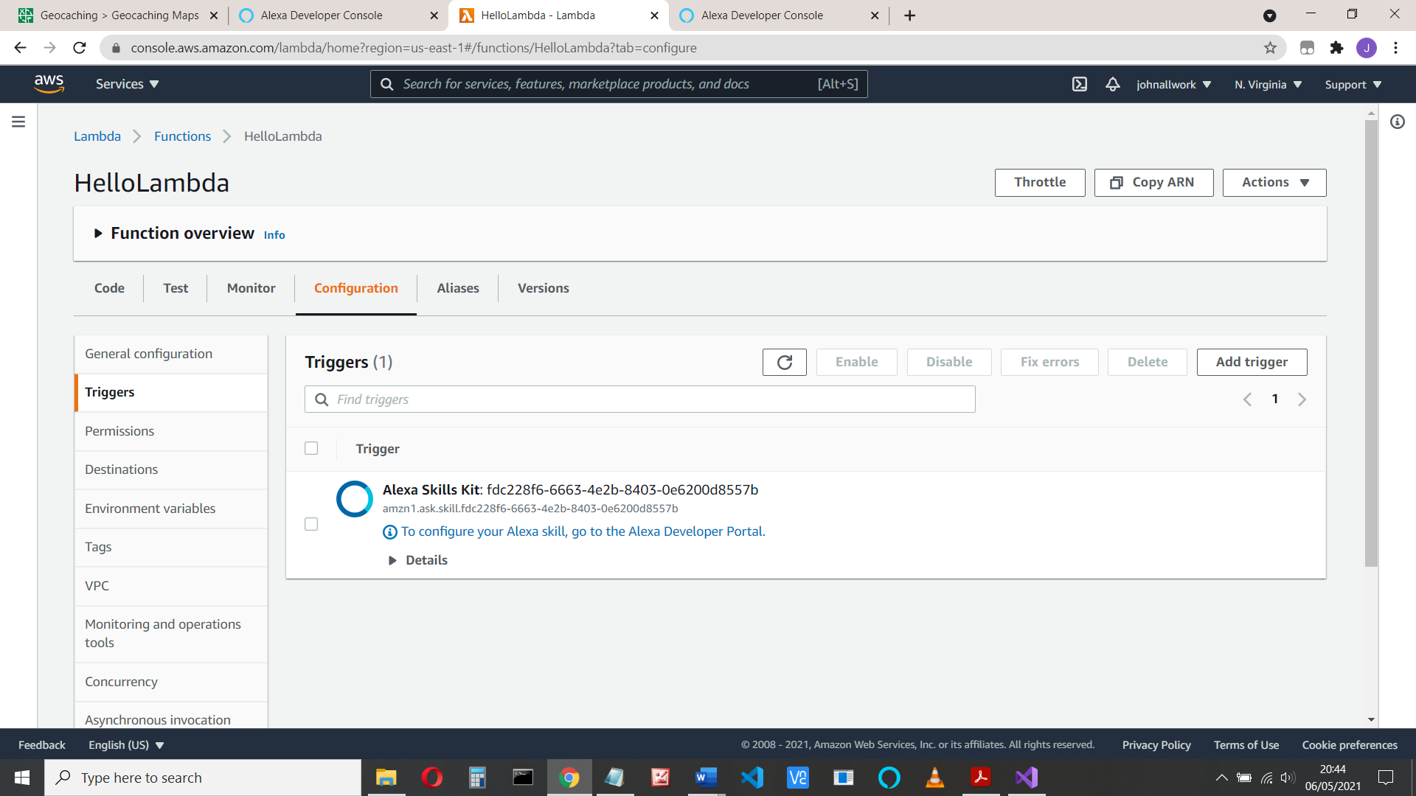

Go to the Developer Portal (developer.amazon.com) to configure the Utterances and intents

**Part 4 – Configure endpoints, and add utterances and intents**

Your Alexa skill knows about your lambda code, but not the other way, so add the ARN you copied (remember that *) to the Default region in your endpoints:

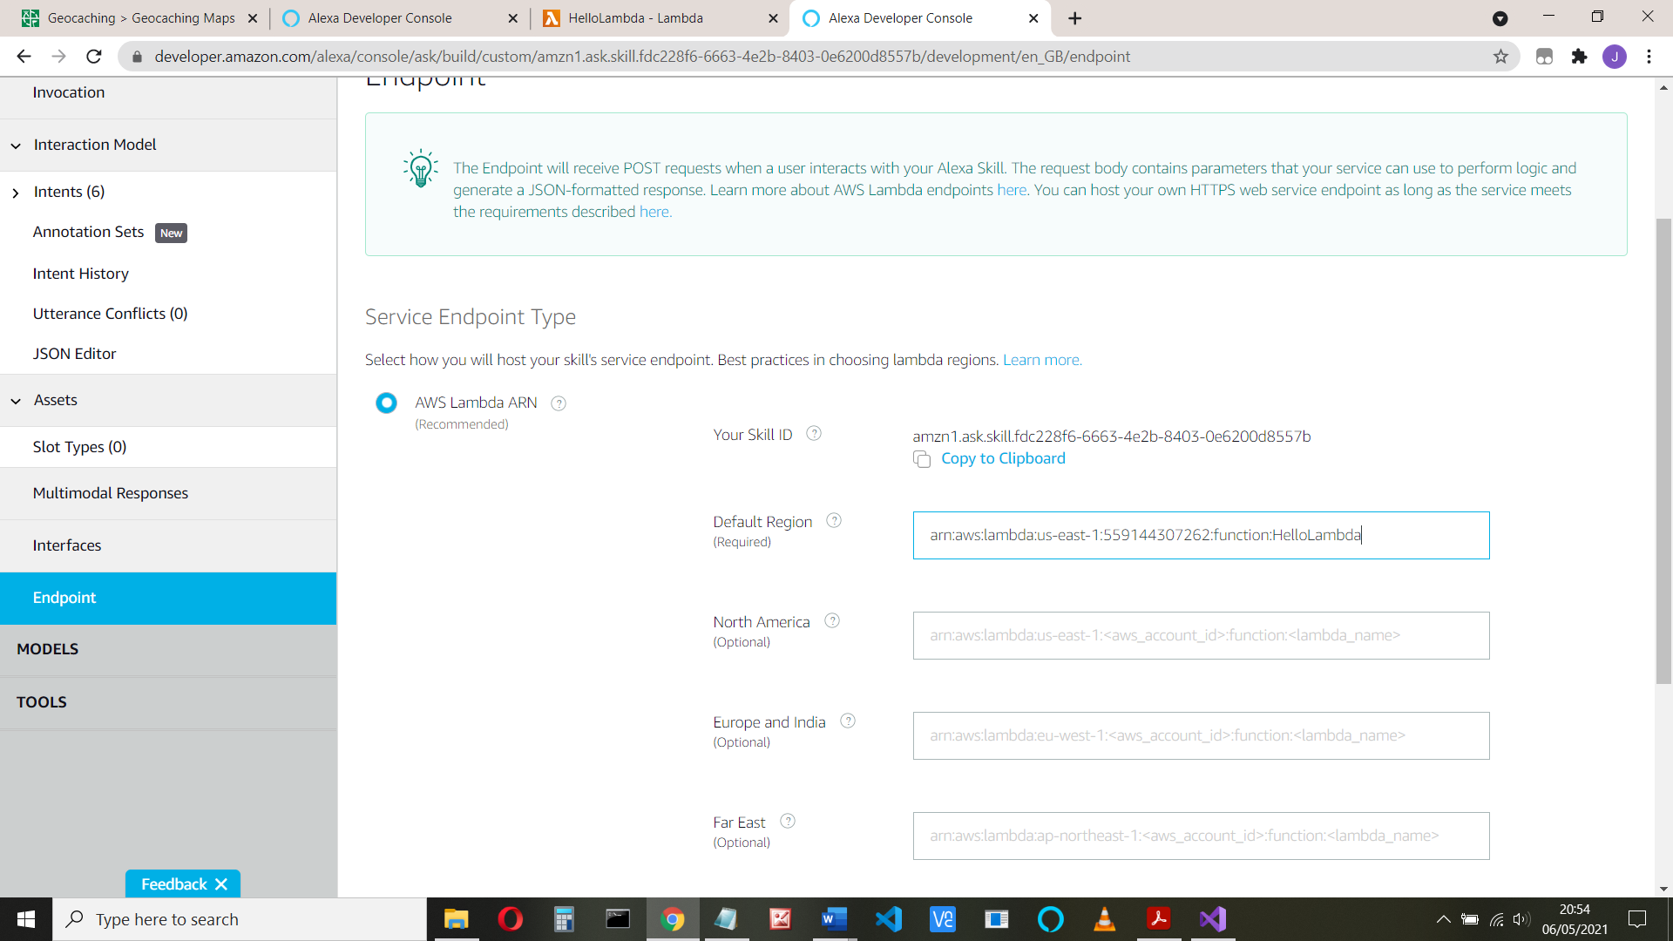

(It’s something like arn:aws:lambda:us-east-1:55914123452:function:HelloLambda)

And save the endpoints

**Add your intent**

Select Intents from the left-hand side.

Our code has the AMAZON intents: Cancel, Stop and Help and our Hellointent:

case "HelloIntent":

log.LogLine($"Say Hello");

innerResponse = new PlainTextOutputSpeech();

(innerResponse as PlainTextOutputSpeech).Text = "Hello from Johns Calculator";

There’s already a HelloWorldIntent. Delete that.

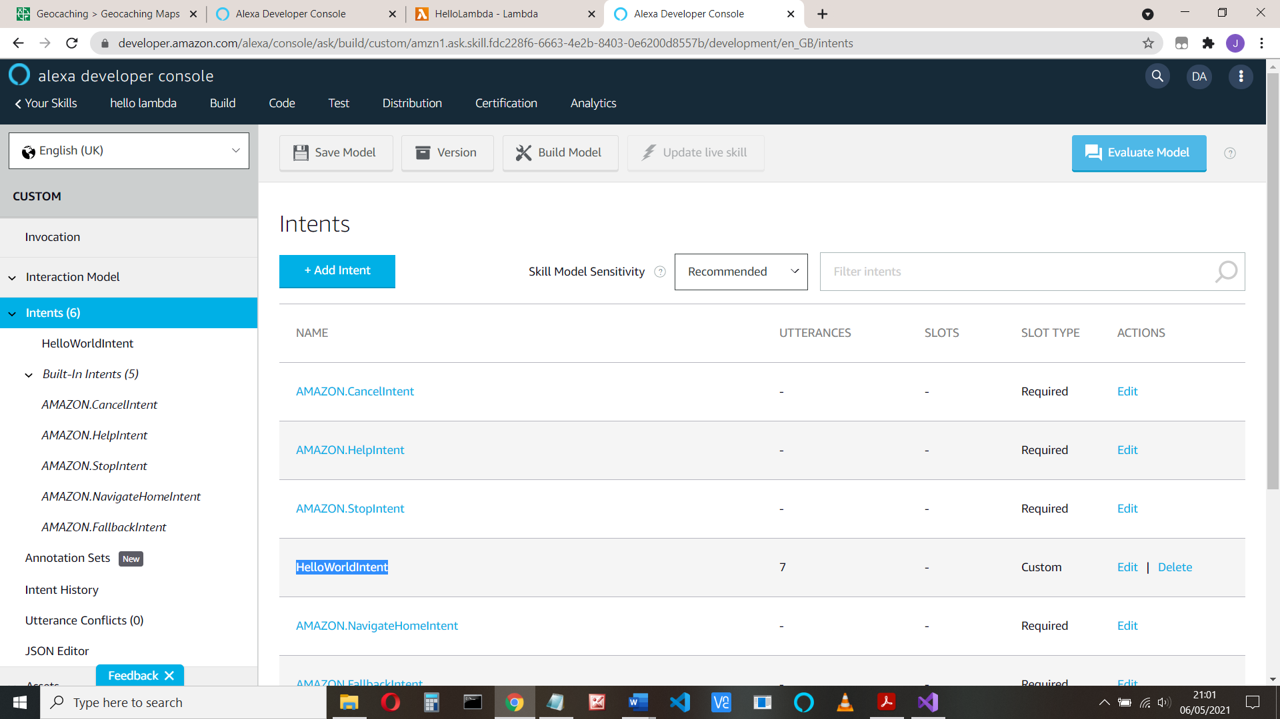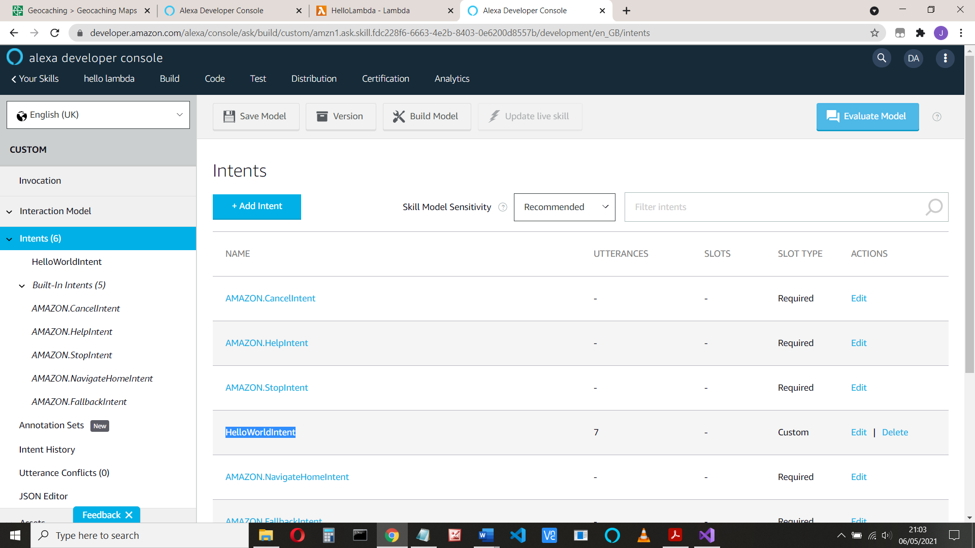

Now click Add Intent and add an intent called HelloIntent (this must match your code)

Click Create Custom Intent and add some utternaces :

Hi, Hello, good morning, etc:

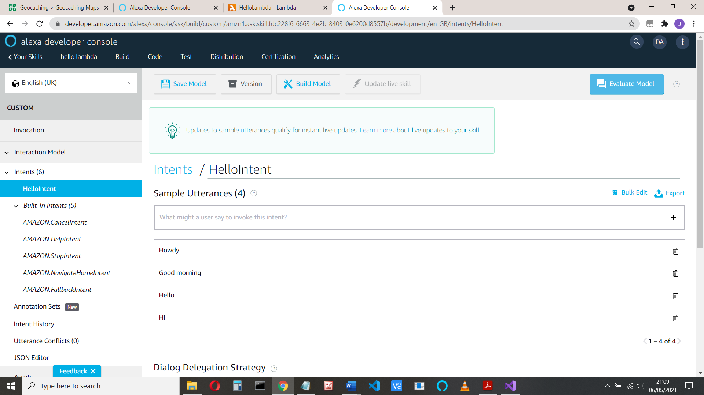

And save and build the model (at the top of the page)

**Let’s test it**

When the build id done, click the Test tab at the top and

Enable the skill for Development testing:

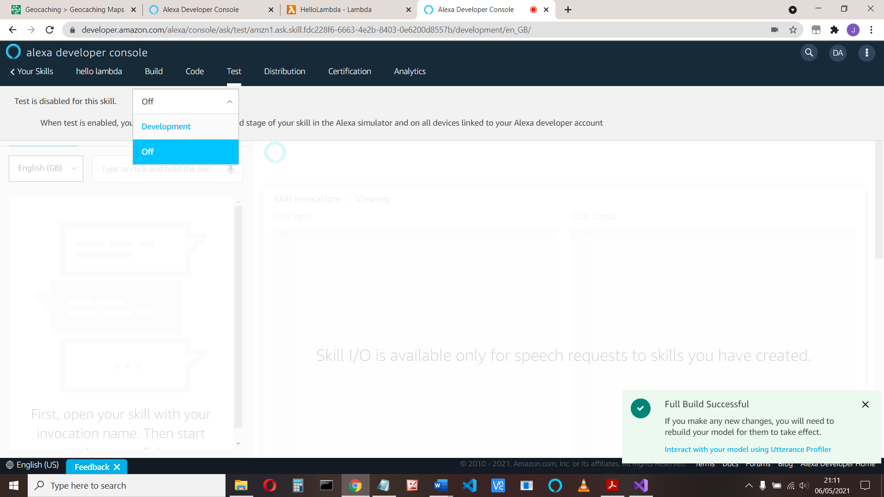

Type in or say “open hello lambda”

You should get a spoken response: Launch Request. Calculator opened

And if you type “hello”, the response: Hello from Johns Calculator

If that works, well done!

You can see the request to your program, and its response:

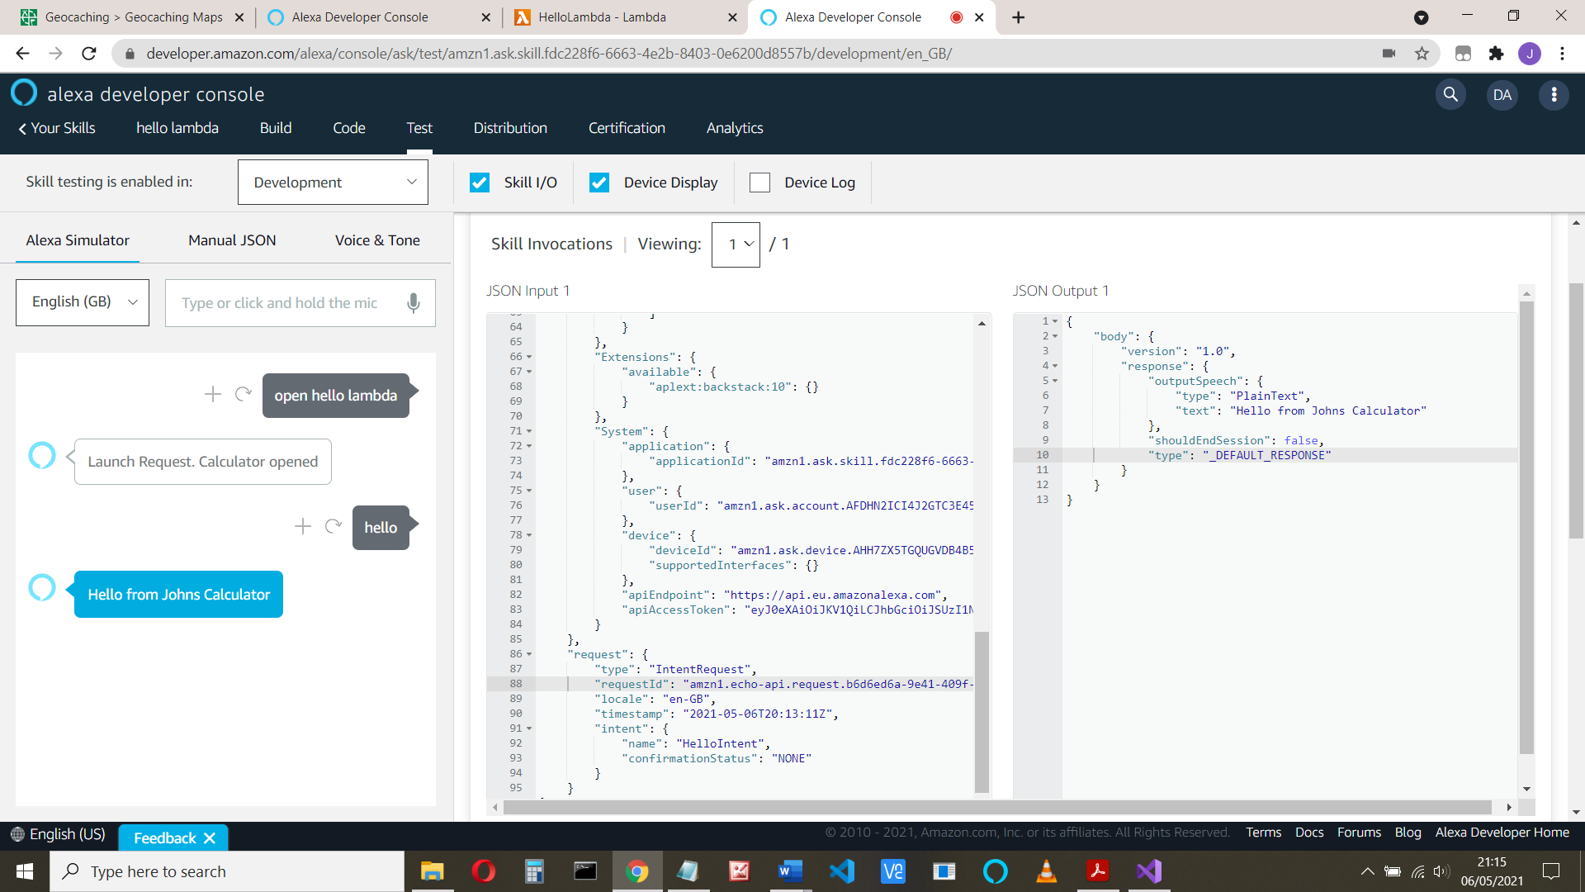

Ok time to try it on your device!

**Part 5 – using slots**

Slots are how data is passed from your VUI to your program. As an example, we will get Alexa / your program to ask for your name.

The VUI might go like this:

Alexa: Welcome, please tell me your name

User: My name is John (John will be passed from Alexa to your program in a slot)

Alexa: Hello John (Your program picks John from the Alexa request and responds)

1. Start a new C# program,

Replace the function.cs code with the following:

using Amazon.Lambda.Core;

using Alexa.NET.Response;

using Alexa.NET.Request;

using Alexa.NET.Request.Type;

using Newtonsoft.Json;

using System.Collections.Generic;

using System;

// Assembly attribute to enable the Lambda function's JSON input

// to be converted into a .NET class.

[assembly: LambdaSerializer(typeof(Amazon.Lambda.Serialization.Json.JsonSerializer))]

namespace PersonalHello

{

public class Function

{

int count;

// string MYNAME = "myname";

string userName;

public SkillResponse FunctionHandler(SkillRequest input, ILambdaContext context)

{

SkillResponse response = new SkillResponse();

response.Response = new ResponseBody();

response.Response.ShouldEndSession = false;

IOutputSpeech innerResponse = null;

var log = context.Logger;

log.LogLine($"Skill Request Object:");

log.LogLine(JsonConvert.SerializeObject(input));

if (input.GetRequestType() == typeof(LaunchRequest))

{

count = 0;

userName = null;

log.LogLine($"Default LaunchRequest made");

innerResponse = new PlainTextOutputSpeech();

(innerResponse as PlainTextOutputSpeech).Text = "Hello, What is your name?";

}

else if (input.GetRequestType() == typeof(IntentRequest))

{

var intentRequest = (IntentRequest)input.Request;

switch (intentRequest.Intent.Name)

{

case "AMAZON.CancelIntent":

log.LogLine($"AMAZON.CancelIntent: send StopMessage");

innerResponse = new PlainTextOutputSpeech();

(innerResponse as PlainTextOutputSpeech).Text = "Cancelled";

response.Response.ShouldEndSession = true;

break;

case "AMAZON.StopIntent":

log.LogLine($"AMAZON.StopIntent: send StopMessage");

innerResponse = new PlainTextOutputSpeech();

(innerResponse as PlainTextOutputSpeech).Text = "Stopping";

response.Response.ShouldEndSession = true;

break;

case "AMAZON.HelpIntent":

log.LogLine($"AMAZON.HelpIntent: send HelpMessage");

innerResponse = new PlainTextOutputSpeech();

(innerResponse as PlainTextOutputSpeech).Text = "Help me!";

break;

case "HelloIntent":

count++;

log.LogLine($"Say Hello");

// they might want to change their name

if (Convert.ToString(intentRequest.Intent.Slots["myname"].Value) == null)

// no name passed. Use anon if new, or use the name we know

{

if (userName == null) // we don't know their name, call them anon

{

userName = "anon";

}

}

else // myname has a vlaue, use that

{

userName = Convert.ToString(intentRequest.Intent.Slots["myname"].Value);

}

log.LogLine(userName);

innerResponse = new PlainTextOutputSpeech();

(innerResponse as PlainTextOutputSpeech).Text = $"Hello {userName}, this is the {count}th time.";

break;

default:

log.LogLine($"Unknown intent: " + intentRequest.Intent.Name);

innerResponse = new PlainTextOutputSpeech();

(innerResponse as PlainTextOutputSpeech).Text = "Unknown Intent";

break;

}

}

response.Response.OutputSpeech = innerResponse;

response.Version = "1.0";

log.LogLine($"Skill Response Object...");

log.LogLine(JsonConvert.SerializeObject(response));

return response;

}

}

}